**Trojan Guard (Team 3)**

|  |  |  |  |
| --- | --- | --- | --- |
| Name | Section | BN | Contribution |
| Abdelrahman Mohamed Salem | 2 | 1 | Analysis of the feature |
| Youssef Said Ibrahim Rabie | 2 | 40 | Analysis of the feature |
| Ahmed Fawzy | 1 | 7 | Analysis of the models |
| Ahmed Alaa | 1 | 6 | Analysis of the models |

**Problem Motivation**

Detection of Trojan Traffic using Binary Classification.

**Problem Definition**

In today's technologically advanced world, the threat of cyberattacks has become a significant concern for individuals, businesses, and governments alike. One of the most insidious types of attacks is the Trojan horse, a malicious software that disguises itself as a harmless file or program. Detecting and preventing these attacks is crucial to maintaining the security of our digital systems.

The Trojan horse can penetrate the system or network when they are invited by the users unknowingly through the visiting of unknown and malicious websites or installing the software. So, Trojan horse can be better understood and realized by monitoring the network and capturing the network packet. The present dataset contains the malicious (Trojan category) and benign network packets which can be used to detect Trojan horse.

**Data-Set Link**

<https://www.kaggle.com/datasets/subhajournal/trojan-detection>

**Evaluation Metrics**

1. Accuracy
2. Precision
3. Recall
4. F1-Score
5. Training Time
6. Model Size
7. Prediction Time
8. AUC-ROC graph

**Results**

**Dataset shape**

At the first sight, we have 85 feature with 177482 row, some of which are just constant values, some are in string format, some are just combination of different other included features, others are following a normal distribution, but most don’t follow any kind of distribution as we will see.

**Unimportant Features at first sight**

After examining the dataset, we found that the following features are unimportant:

1. **Timestamp**: it’s a digital record of the date and time when the frame transmitted but for simplicity, we decided to drop this feature as it has nothing to do with today’s attacks, so we didn’t want the dates of the past affect the prediction of today’s attacks.
2. **Flow ID:** it’s just an identifier in string format for the transmission and it’s written as “<source/destination ip> - <source/destination ip> - <destination/source port> - <destination/source port> - <protocol>”. Which makes this feature a string representation for a mix between the features named “source ip”, “destination ip”, “destination port”, “source port”, “protocol”.
3. **record_id:** it represents the id of the record and it has nothing to do with the class of the record.

The above 3 features are marked as non-important as they are either some identifier to the record or combination of other records.

**Train-Split criteria**

We decided as a rule of thumb to first divide the data into 75% training and 25% testing where the analysis will be done only to the training data and we will use the results of the analysis of training data to deal with testing data. We used stratify strategy which make ratio of Class “Trojan” to the ratio of Class “Benign” in training data is equal to that of testing data.

**Training Data at first Sight**

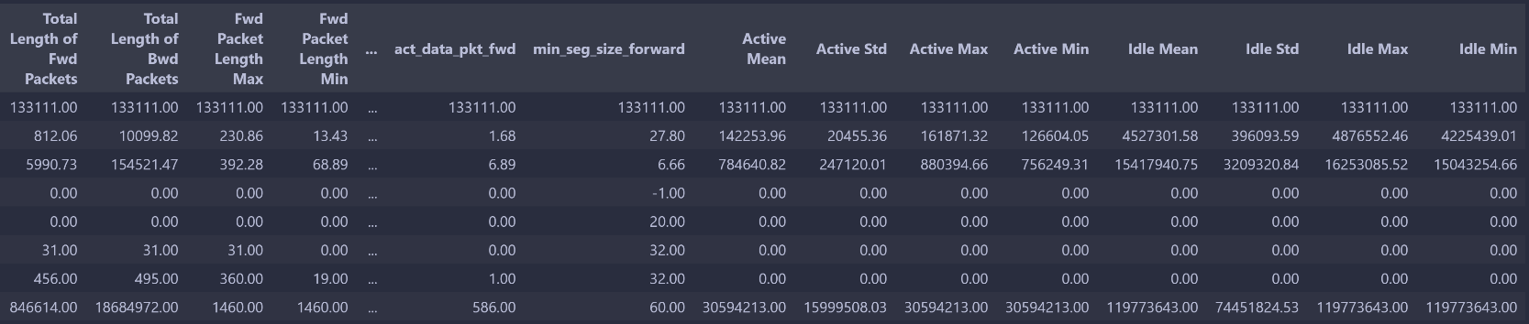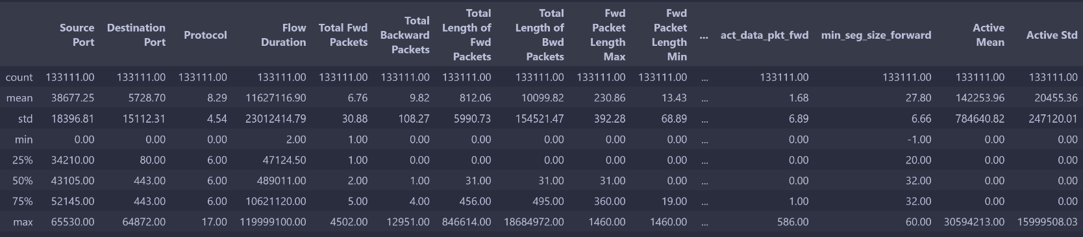As we examine the training data initially, we see that there are some features that have a normal distribution while many others have the value 0 as their Q1, Q2 and Q3 which means that the vast majority of this feature just have the constant value 0.

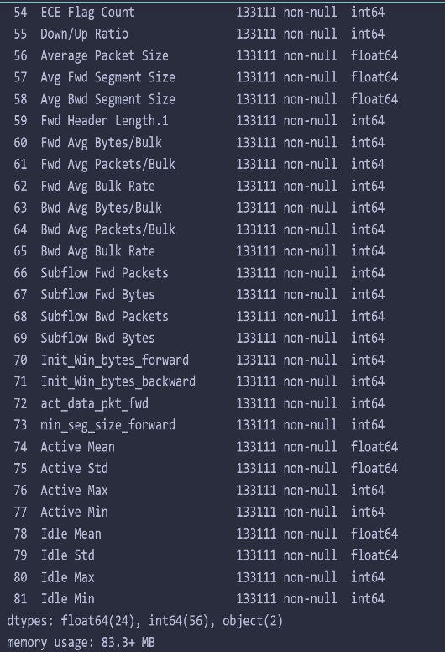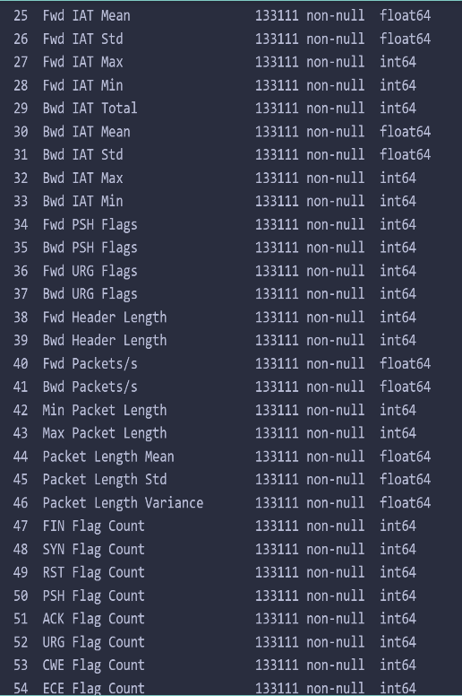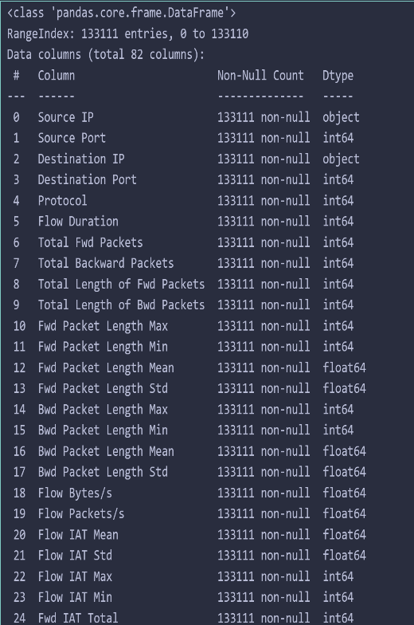Upon examining the datatypes of the features of the dataset, we found that nearly all the feature have either numerical or decimal values except for only 2 features (Source and destination IP)

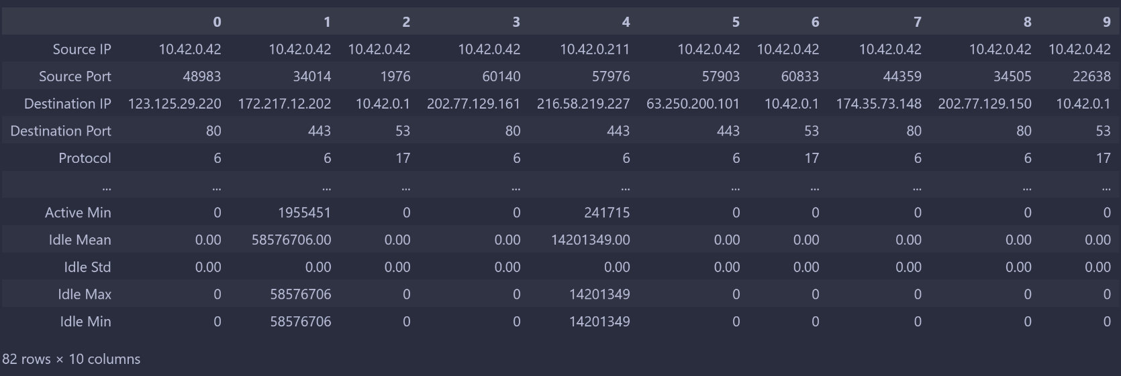

**Non-Important features Due to Analysis**

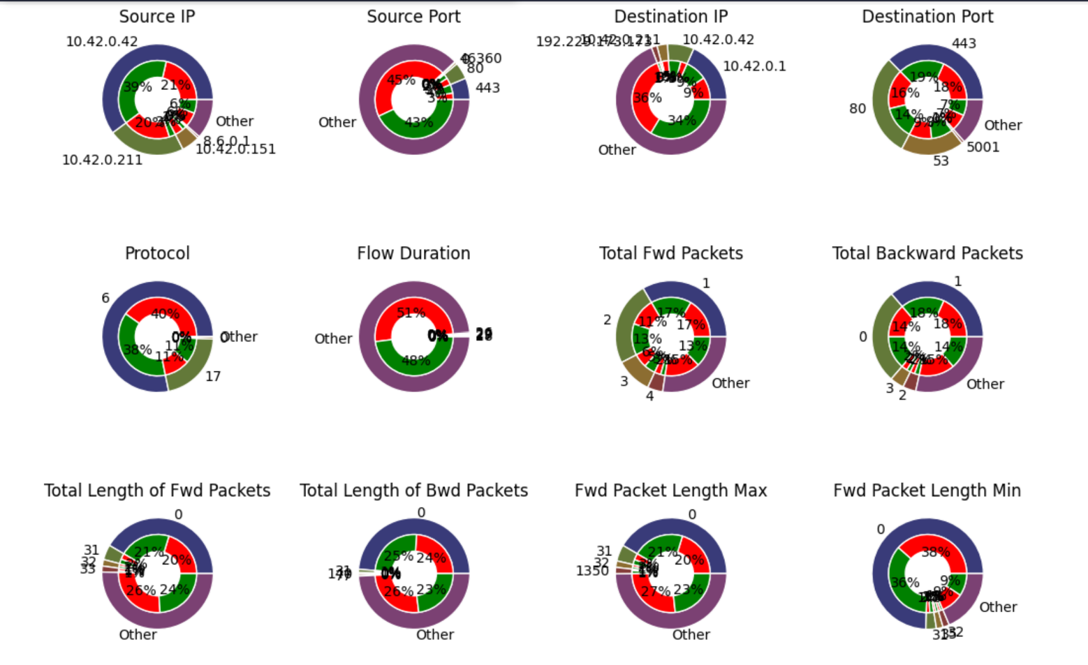We plotted every feature in a pie manner where we choose the most common 4 values for every feature and the fifth is all other features. Then the values of every feature is split into 2 halves (red and green) where red represents the Trojan class and green represents Benign Class. We then colored the Title of every non-important feature that has nearly constant value equally distributed between the 2 classes to be red and next is the visualization.

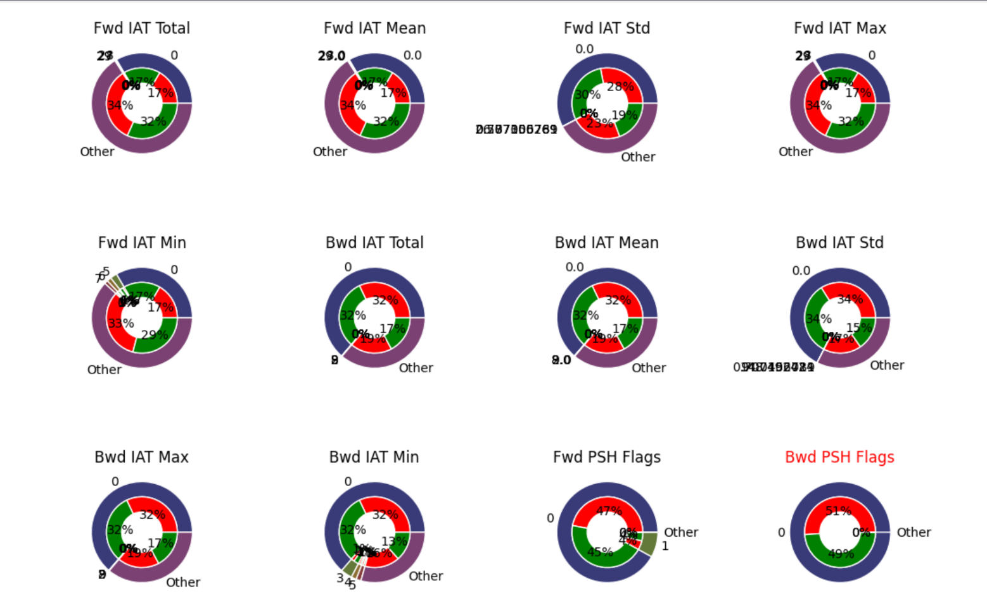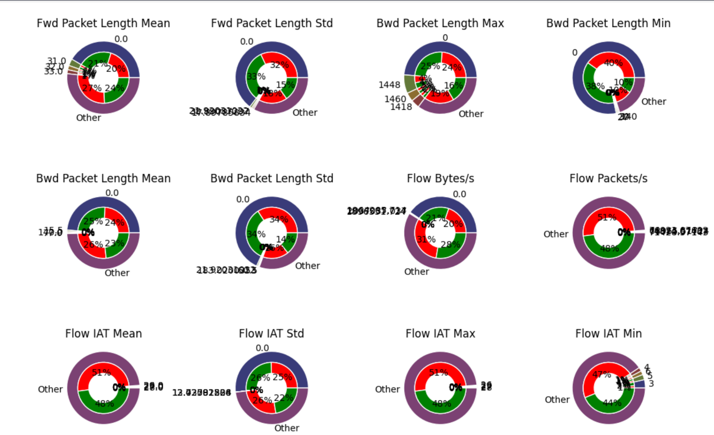

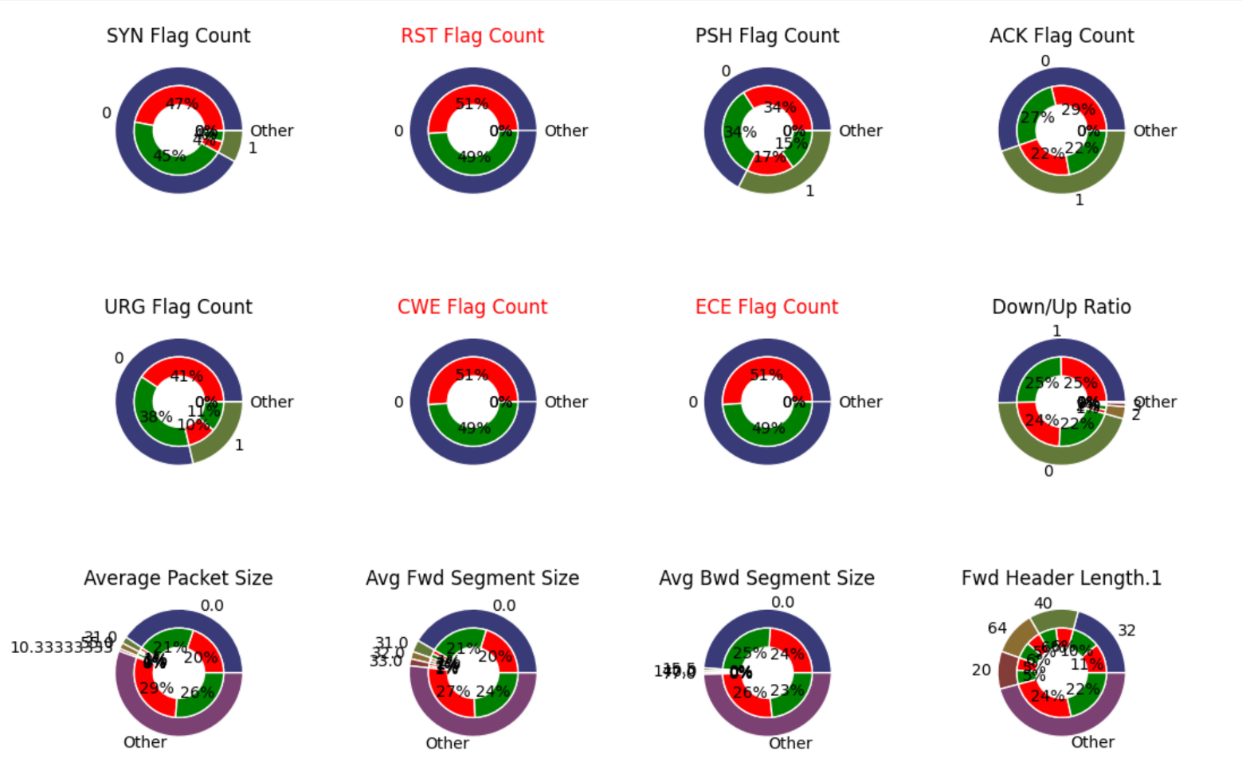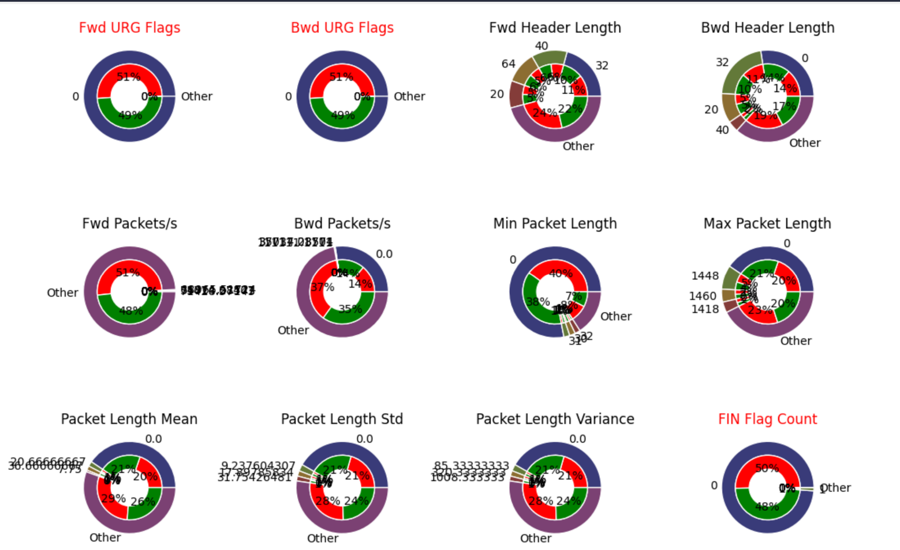

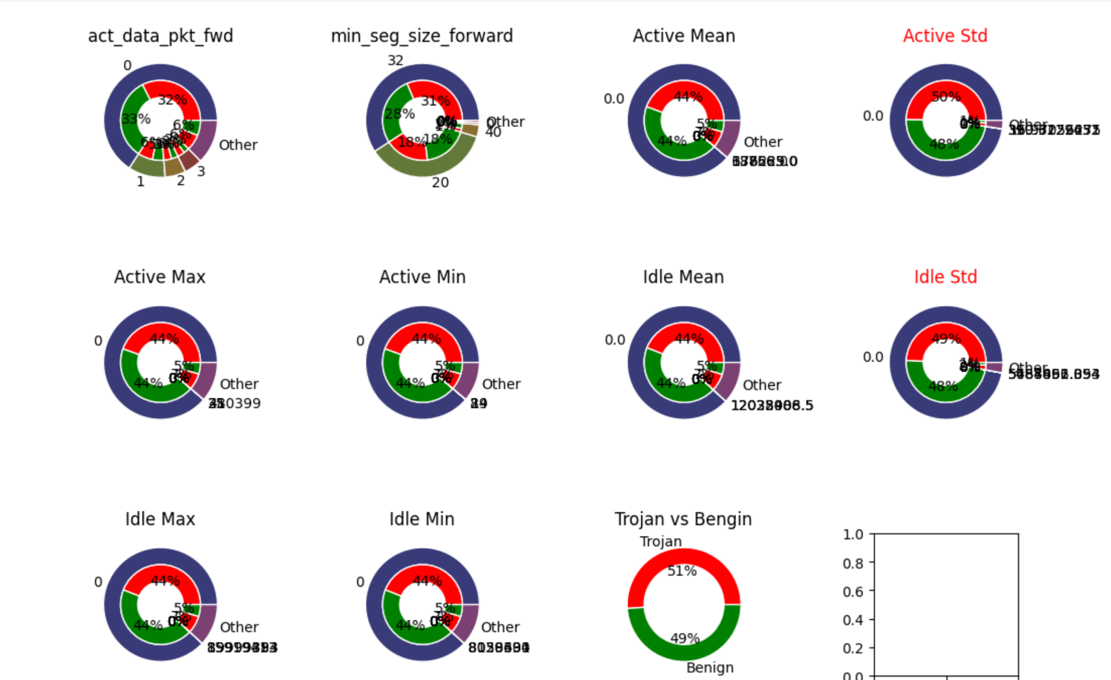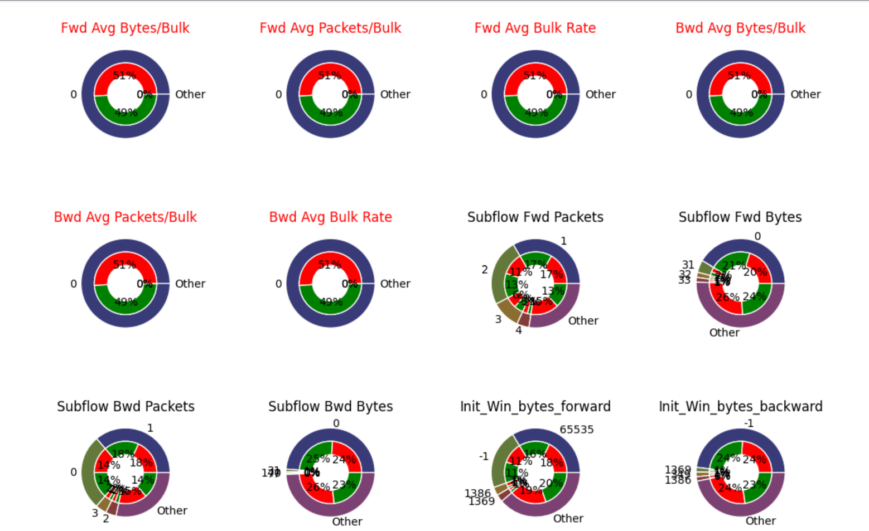

From the above graph we decided to exclude the following for having nearly constant values equally distributed between the 2 classes and we considered the distribution of the constant values because some classifiers like oneR depends on the frequency of a class per a feature:

1. Bwd PSH Flags
2. Fwd URG Flags
3. Bwd URG Flags
4. FIN Flag Count
5. RST Flag Count
6. CWE Flag Count
7. ECE Flag Count
8. Fwd Avg Bytes/Bulk
9. Fwd Avg Packets/Bulk
10. Fwd Avg Bulk Rate
11. Bwd Avg Bytes/Bulk
12. Bwd Avg Packets/Bulk
13. Bwd Avg Bulk Rate
14. Active Std
15. Idle Std

Note that the distribution of the 2 classes (Trojan and Benign) overall the dataset is nearly equal (51:49)

**Conversion of String objects into int**

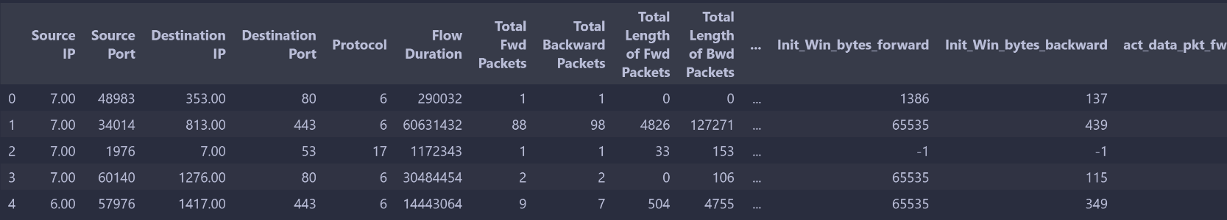We only have 2 object columns in our dataset which are Source IP and destination IP which are in the format ‘A.B.C.D’. We dealt with these columns as labels and since using one hot encoder variables to represent such a column will result in a huge vector space so we use OrdinalEncoder which gives a label for each IP where for example an address of ’10.4.255.1’ will be substituted with 0 for example. Label Encoder which is used with training is used with training data and new IP addresses in test data which is wasn’t seen before will be given a label -1. Classes that has the value Trojan is converted to 1 and Benign is converted to 0.

**Outlier Detection**

We used a voting system where we used around 5 approach to vote for each point to be an outlier or and at the end we consider the point to be an outlier if more than 2 approaches voted for that point to be an outlier. But there are some feature like 'Protocol', 'Source IP', 'Source Port', 'Destination IP', 'Destination Port' where application of outliers on such features doesn’t have a meaning where outliers of such features can be indicated for Trojan points.

**1st Approach**

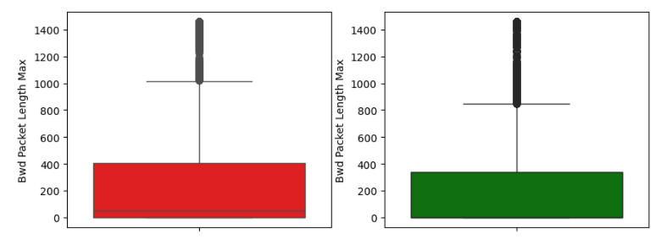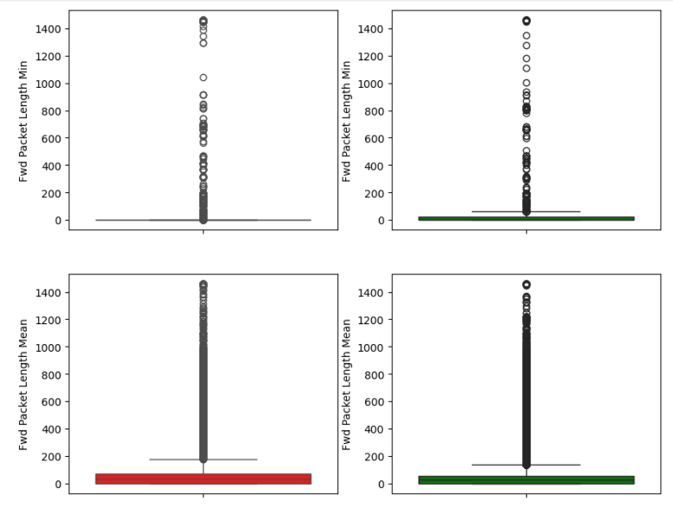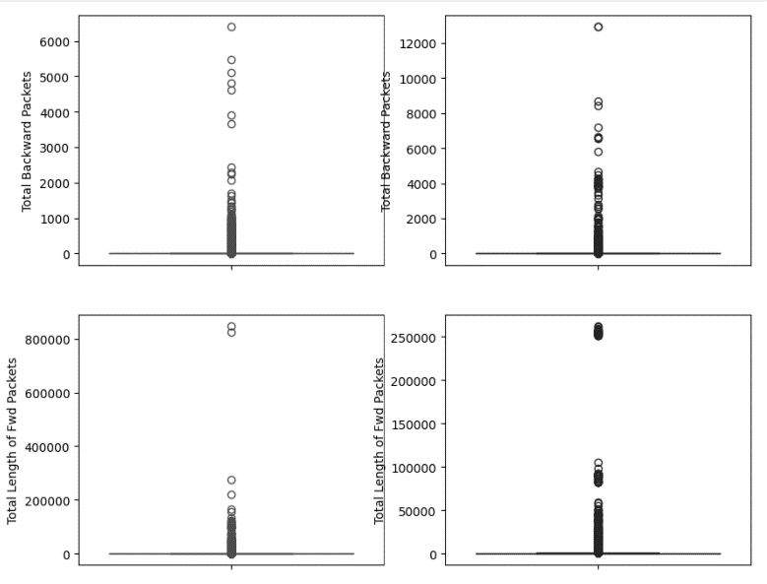We used IQR (interquartile range) to get the outlier where it uses Boxplot and plot Q1, Q2, Q3 for each range per feature per class. Where each point is considered outlier if its feature value is less than (Q1 – IQR) or greater than (Q3 + IQR) where equation of IQR is (Q3 – Q1). (notice how many graph have Q1, Q2 and Q3 nearly same constant value)

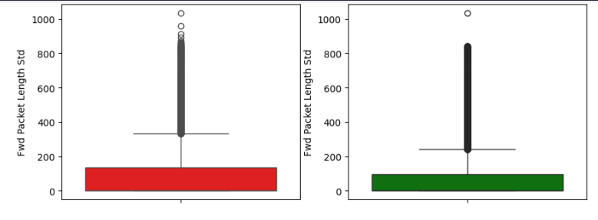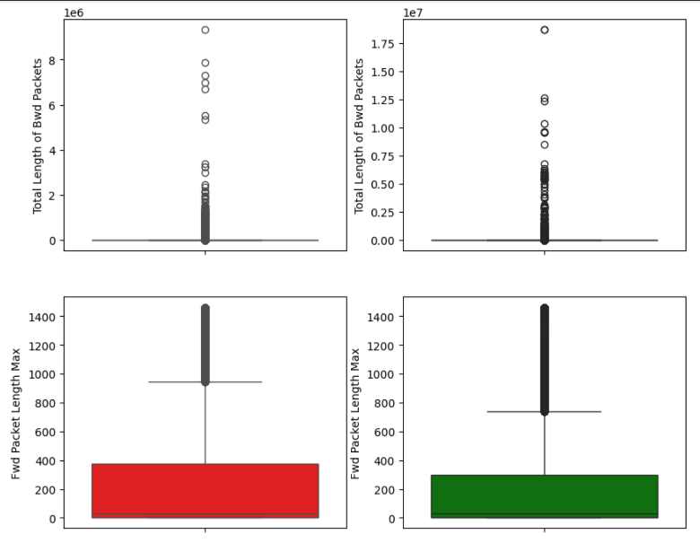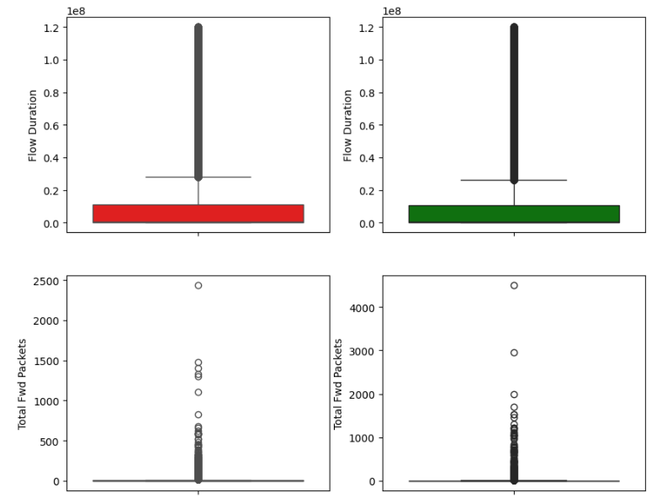

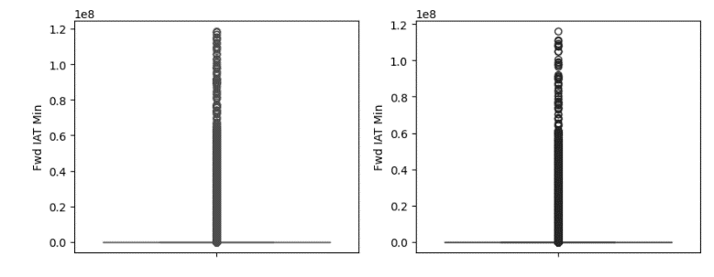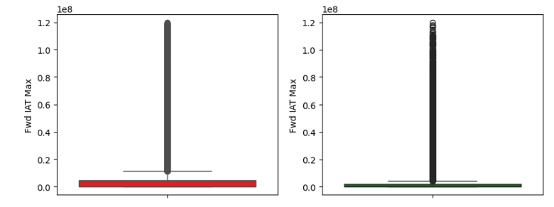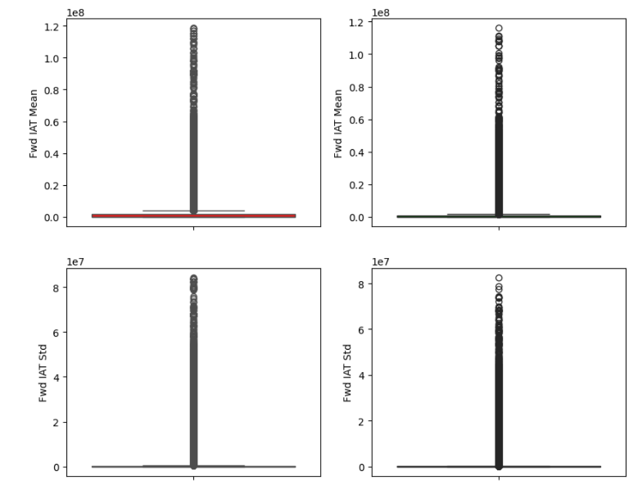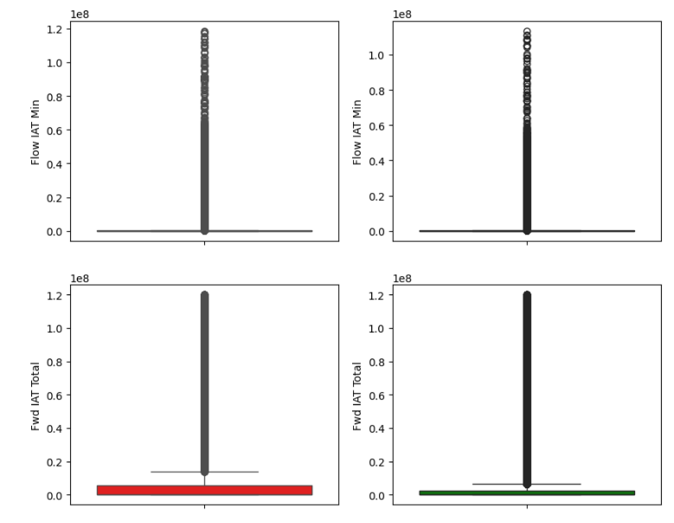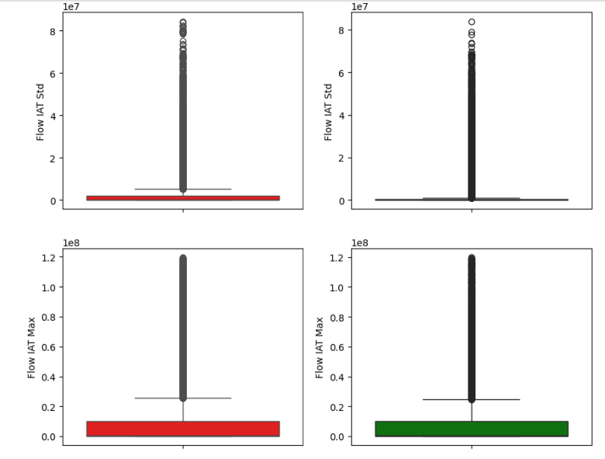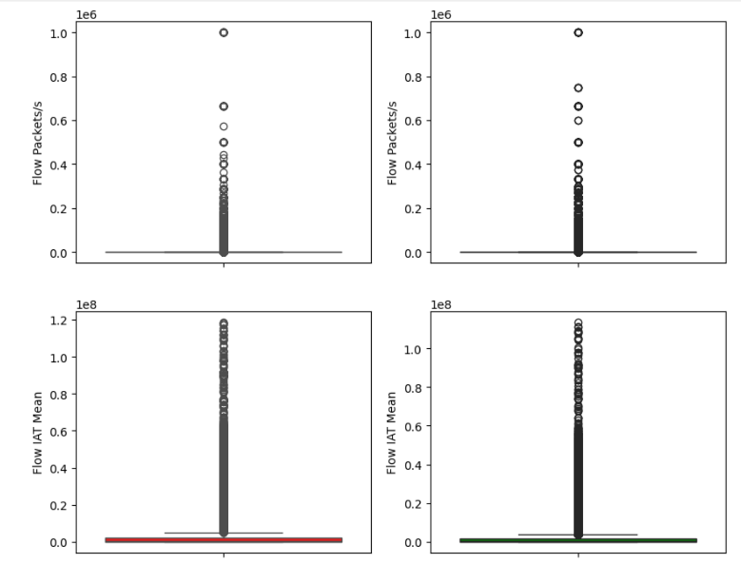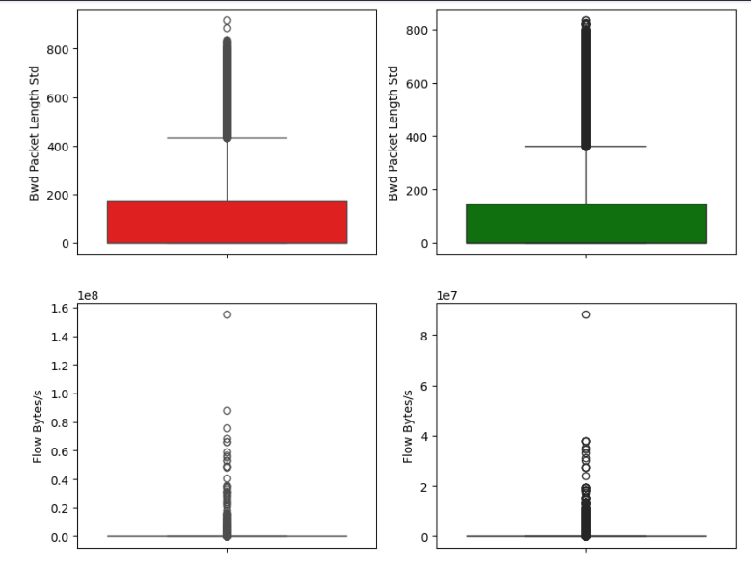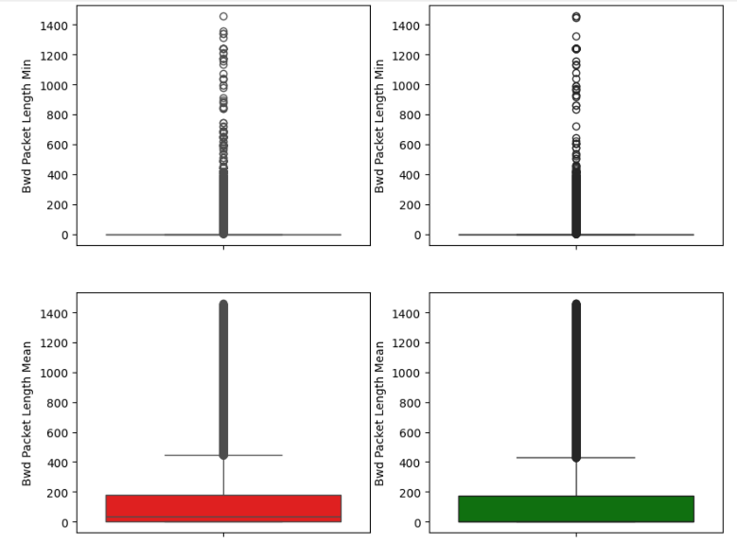

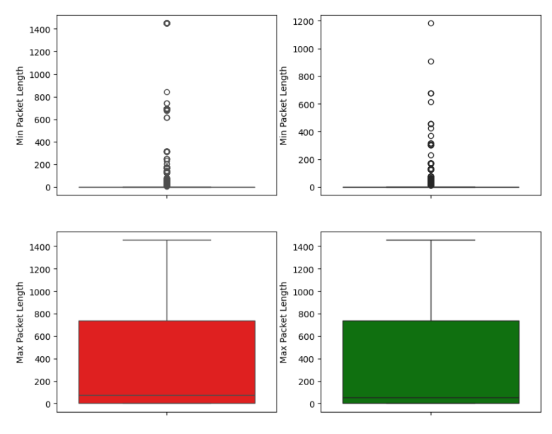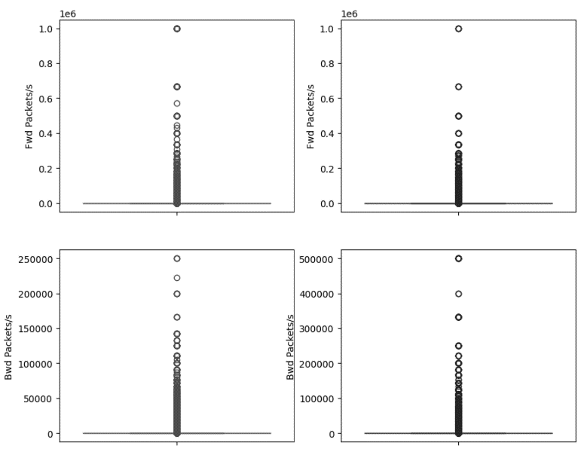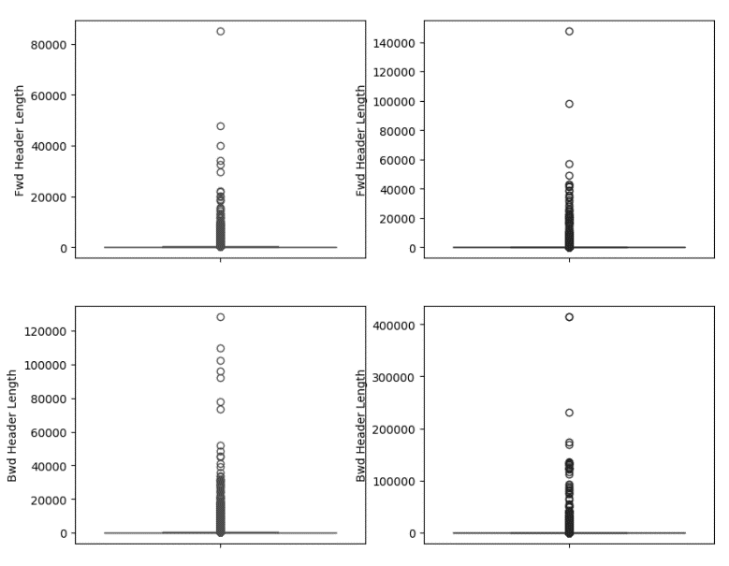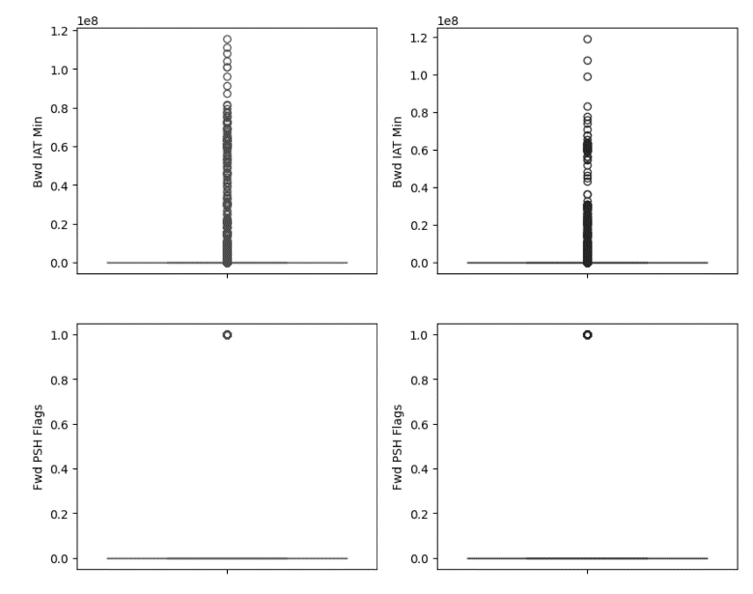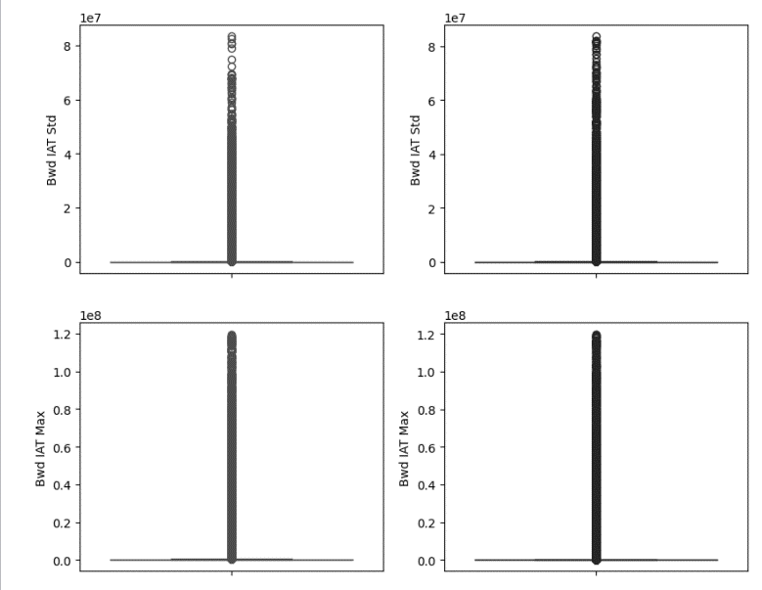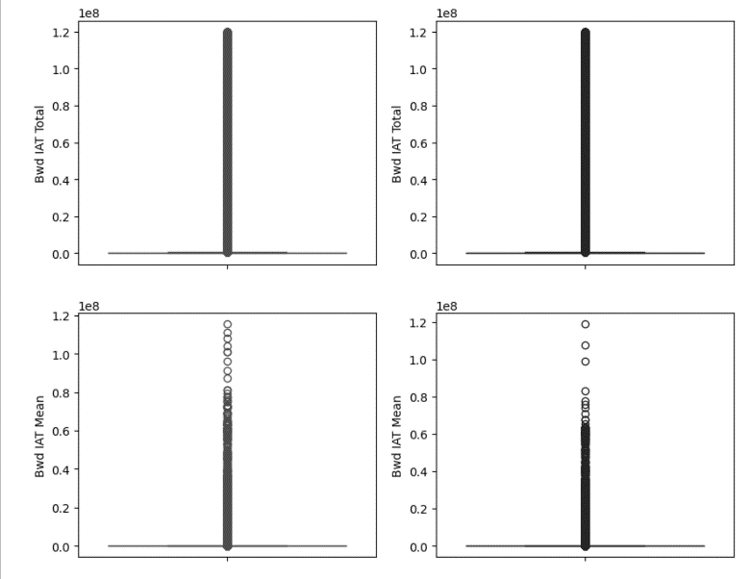

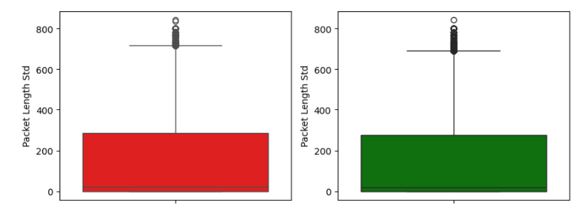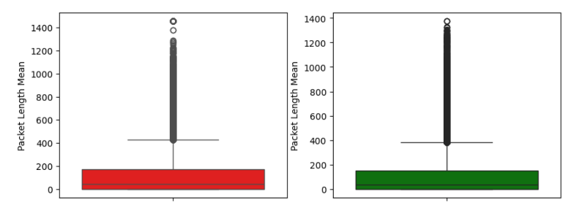

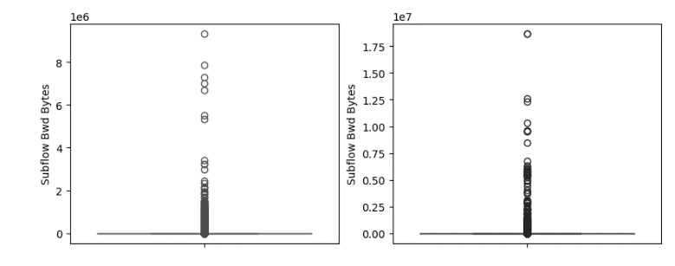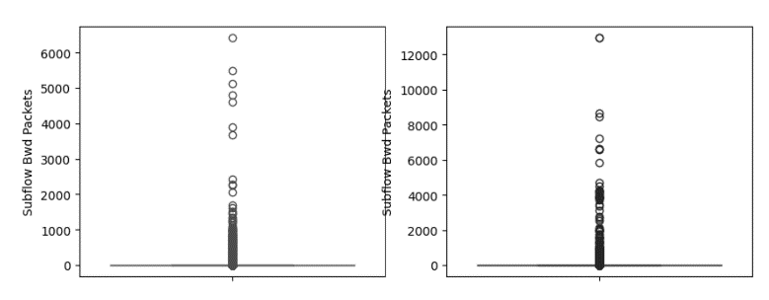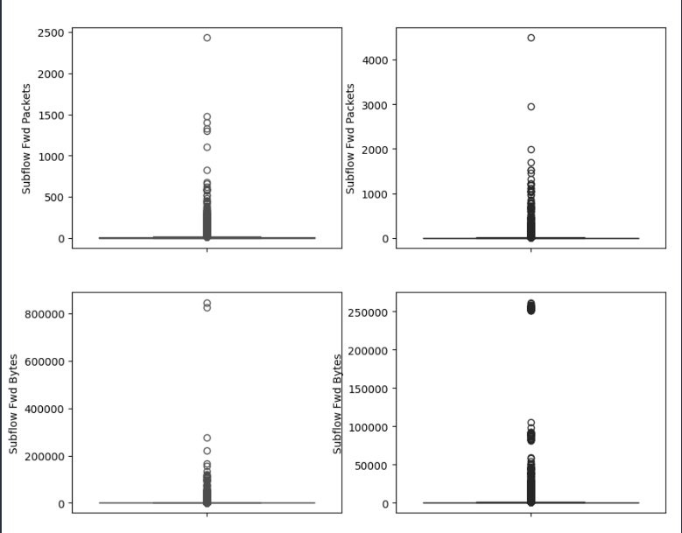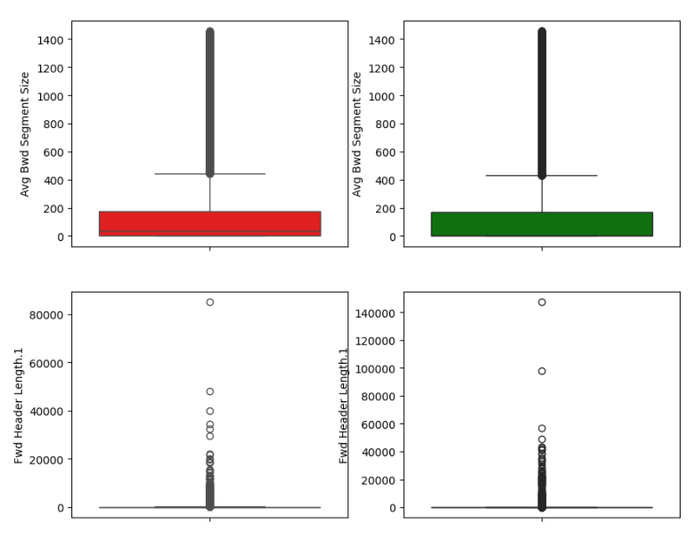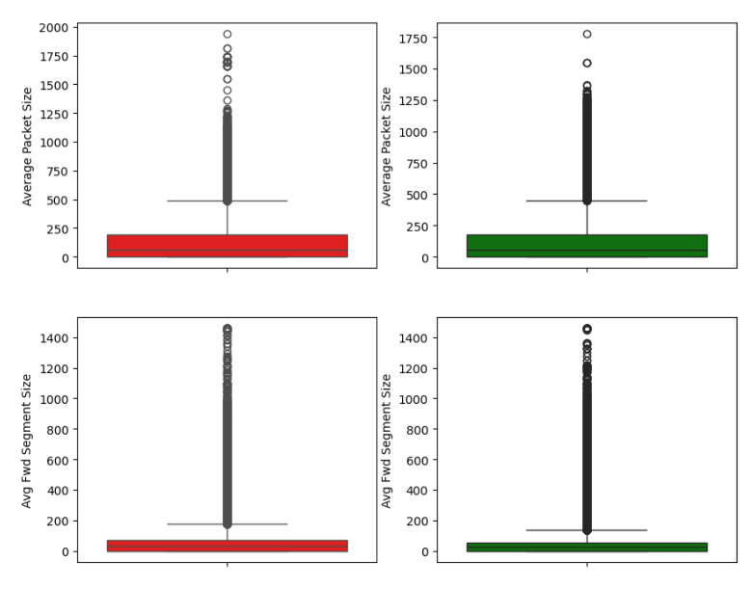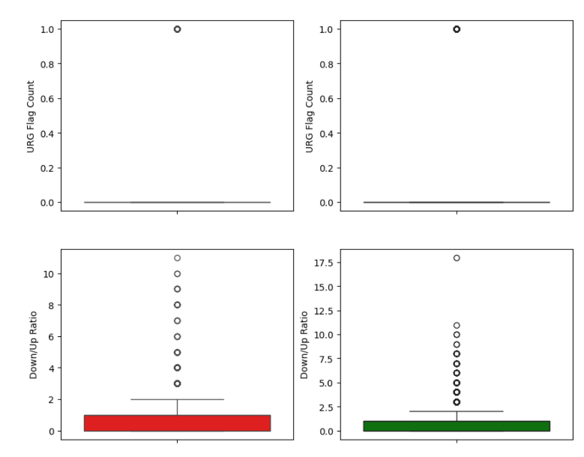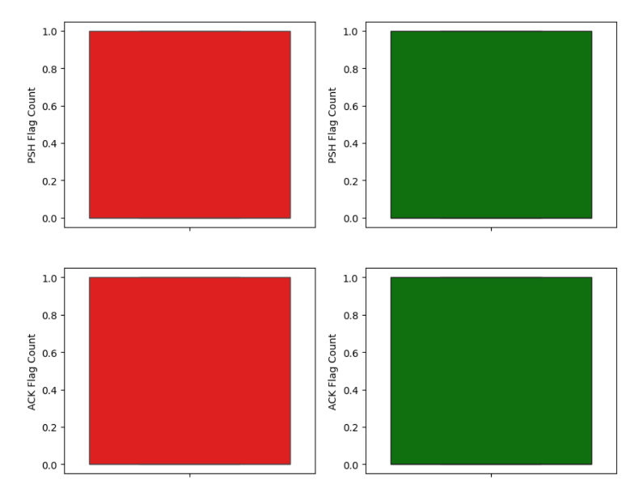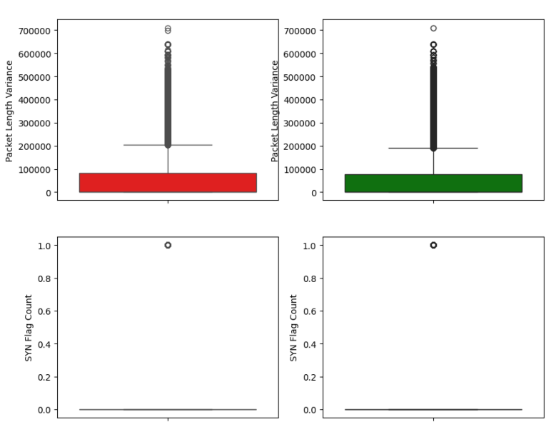

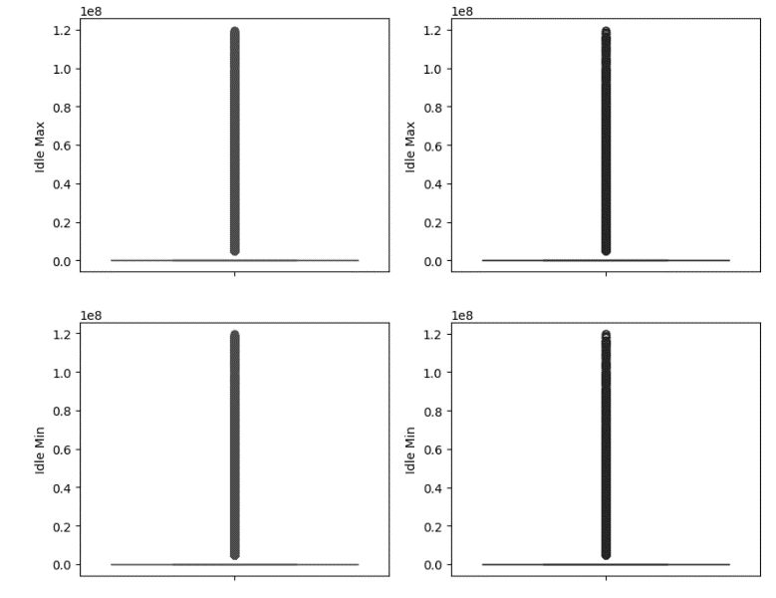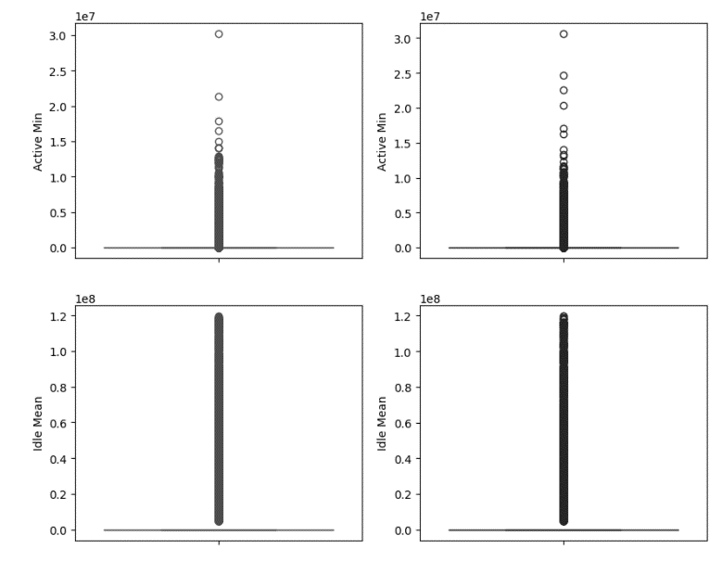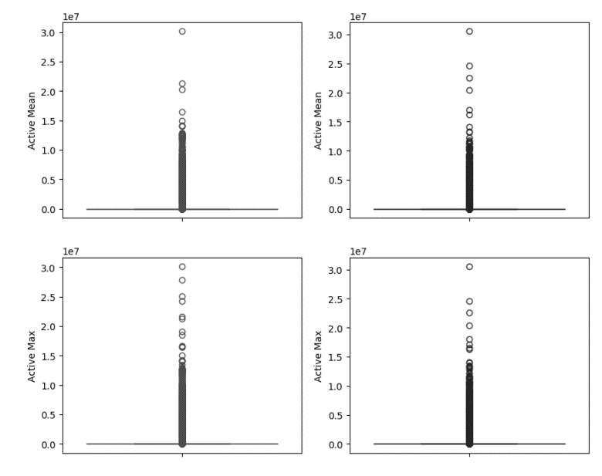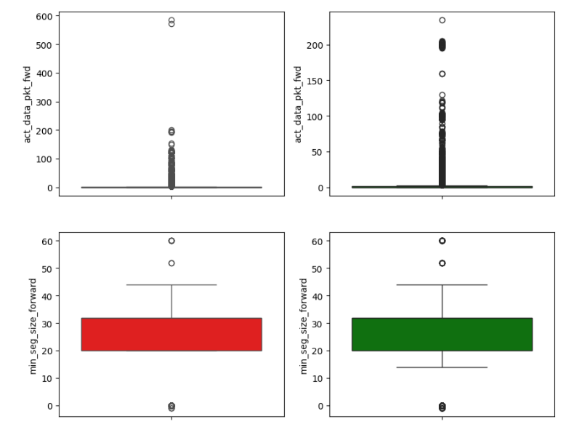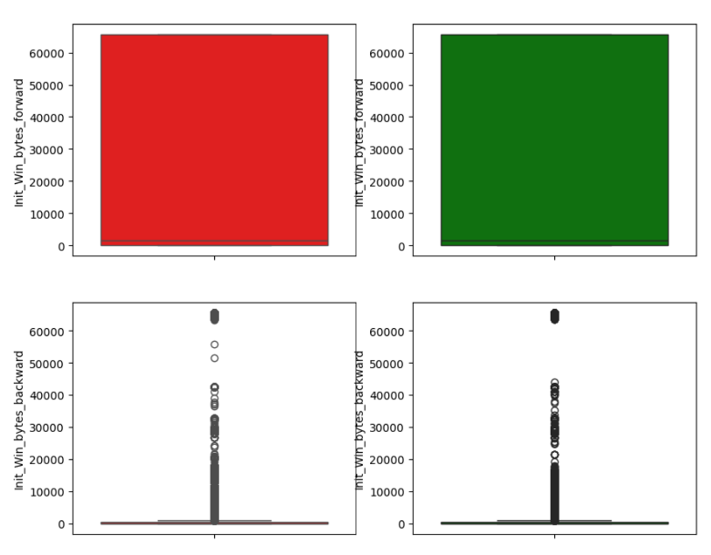

**2nd Approach**

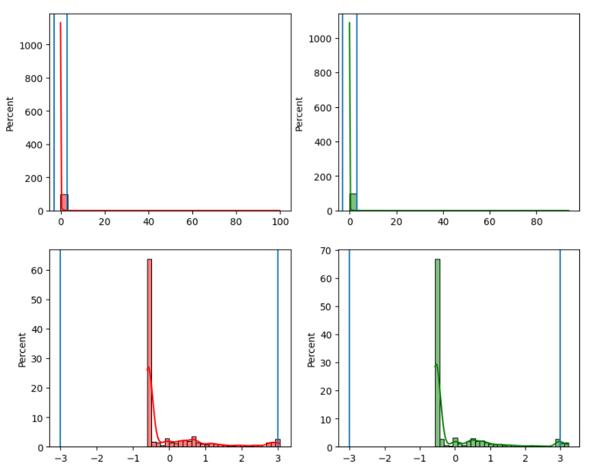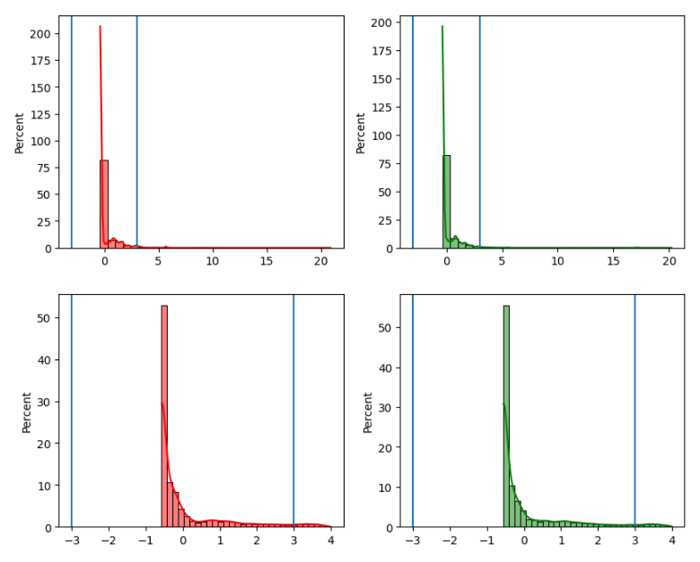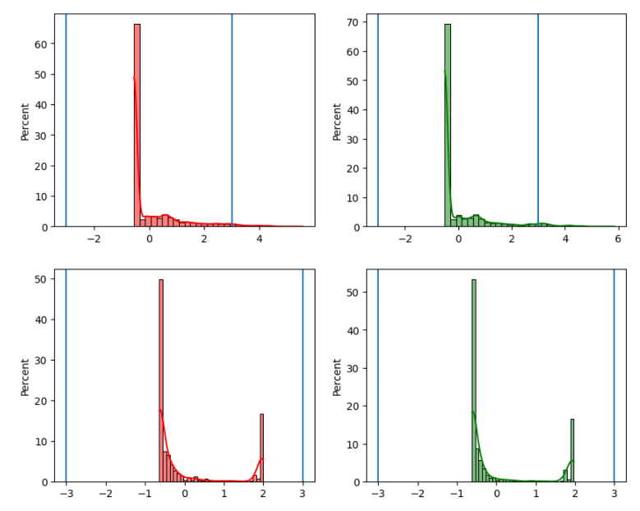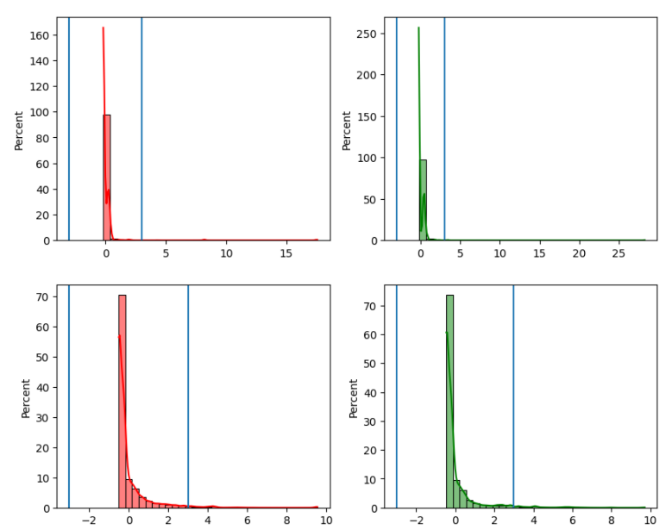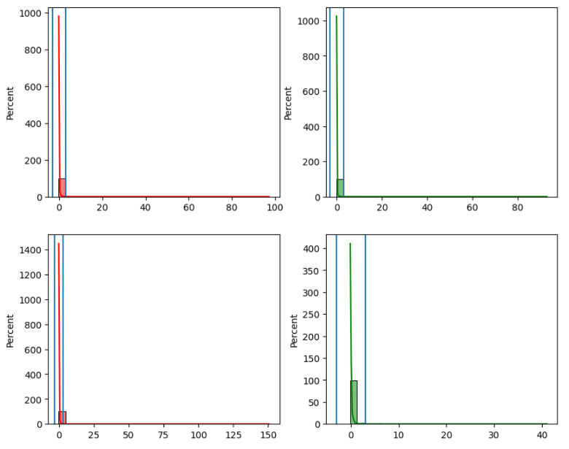We used Z-score where we standardized the features and assumed they follow normal distribution and every value that’s greater than 3 or less than -3 is considered an outlier.

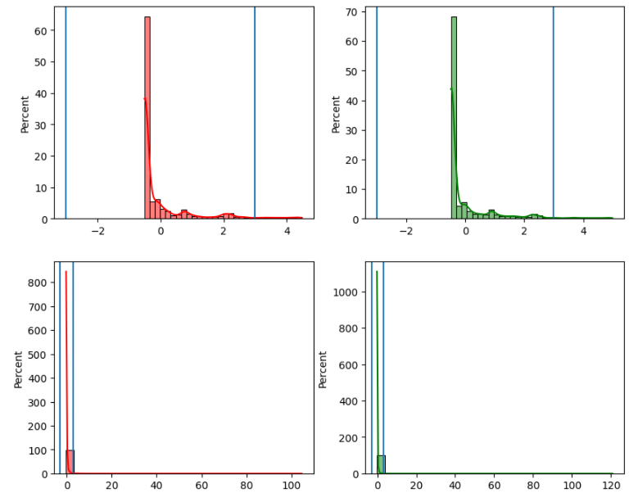

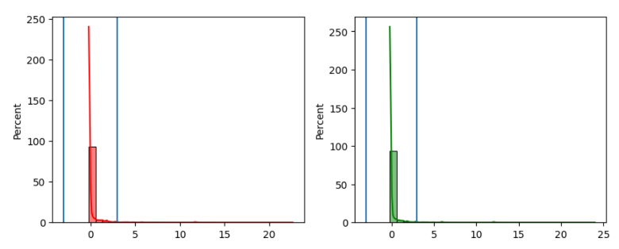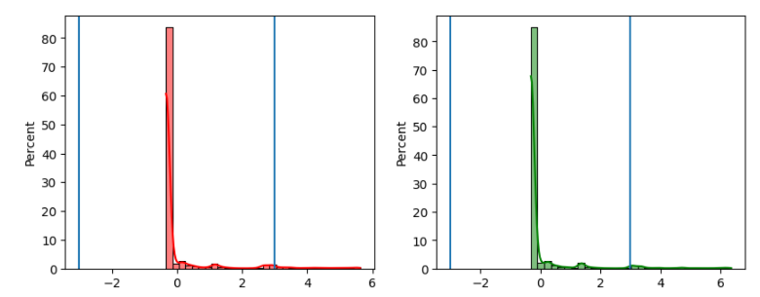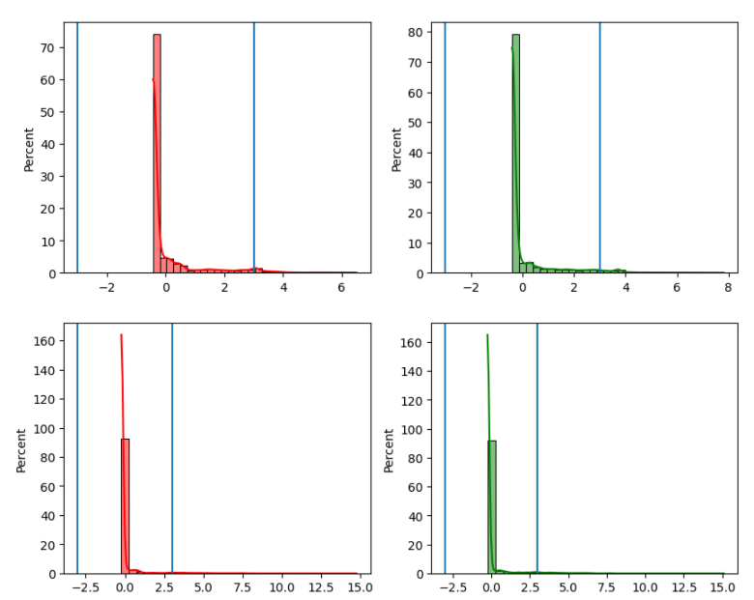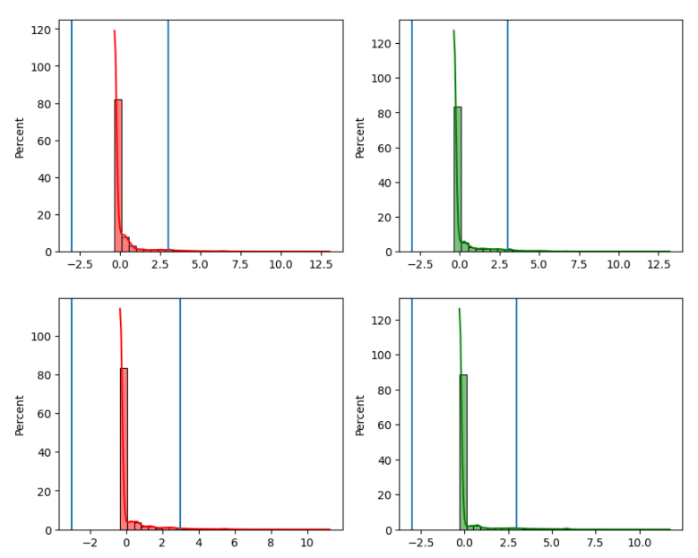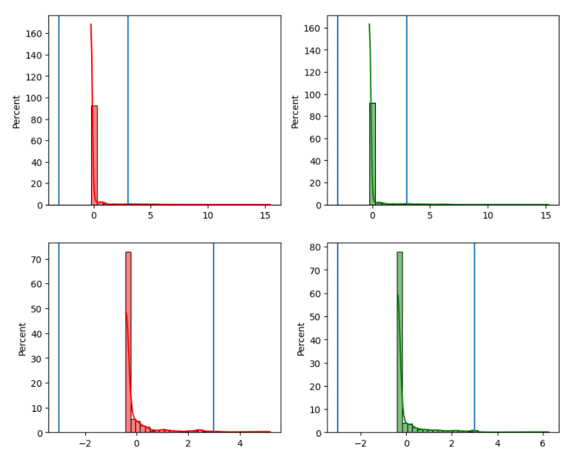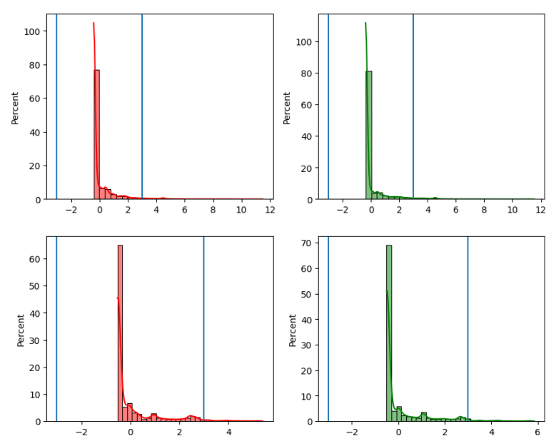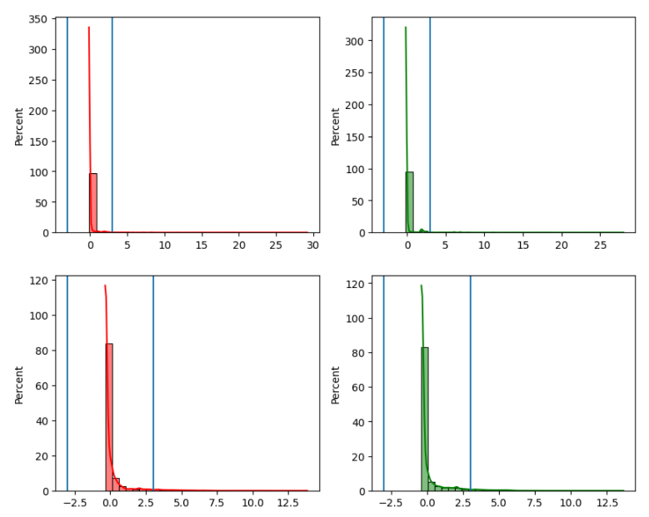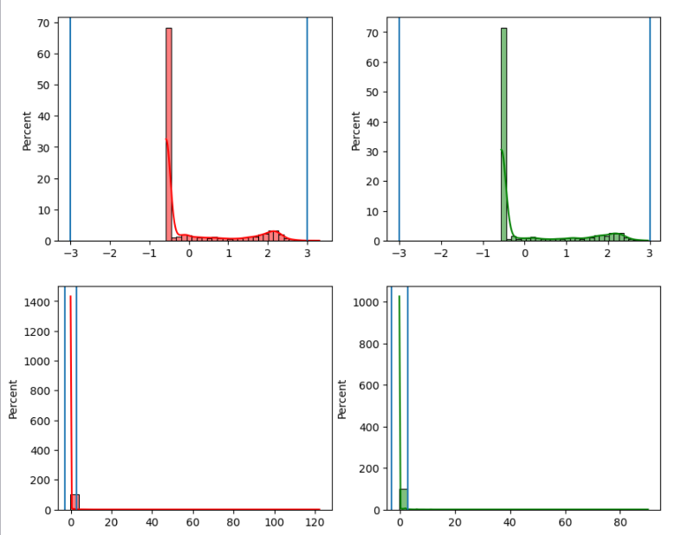

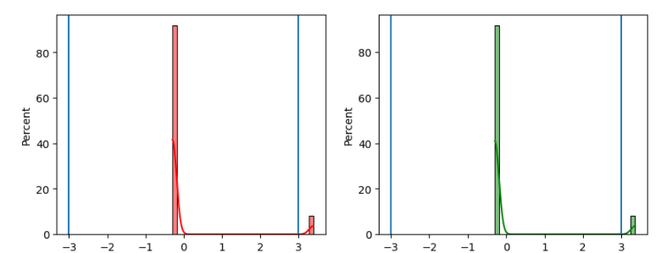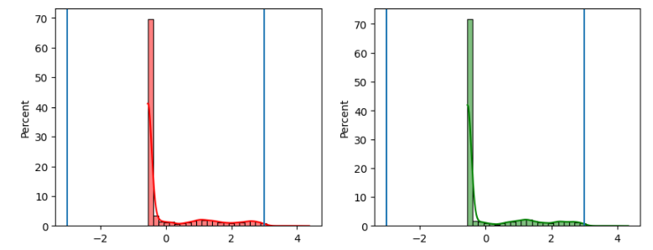 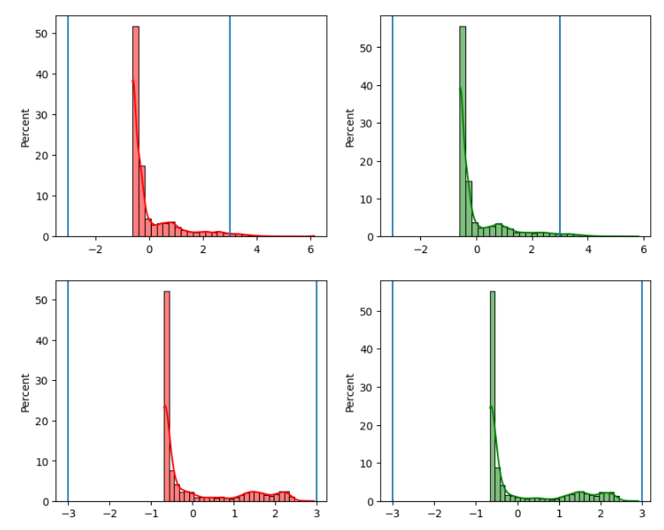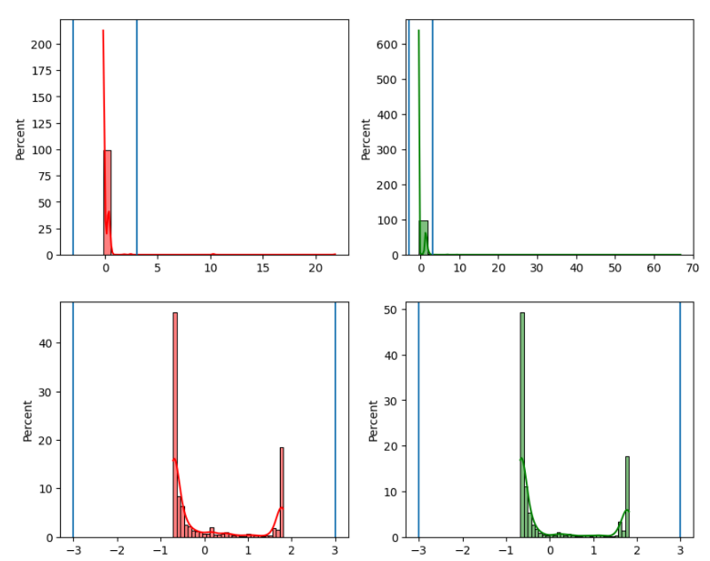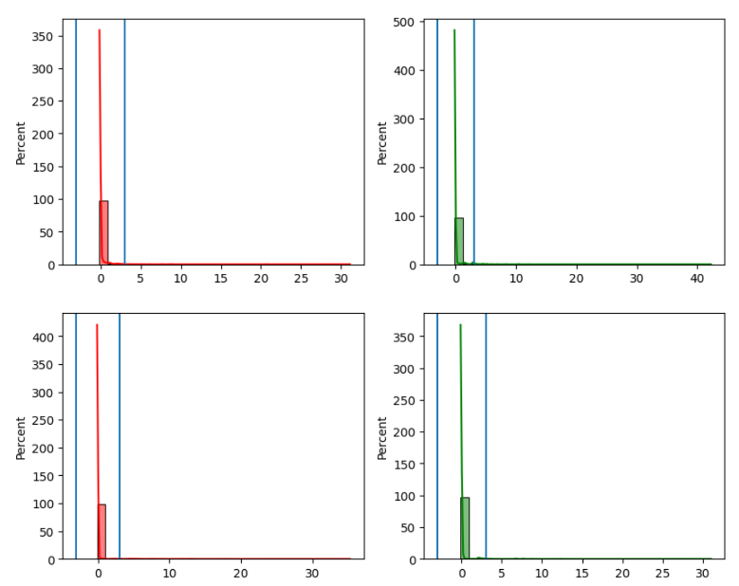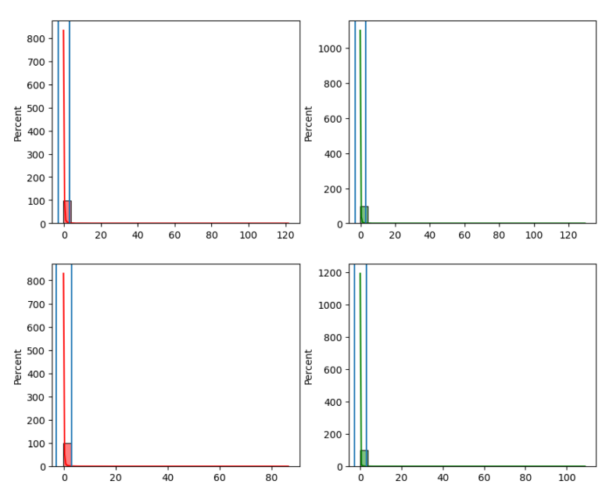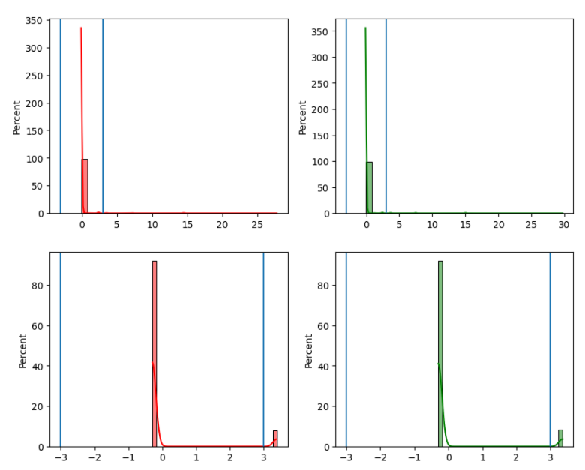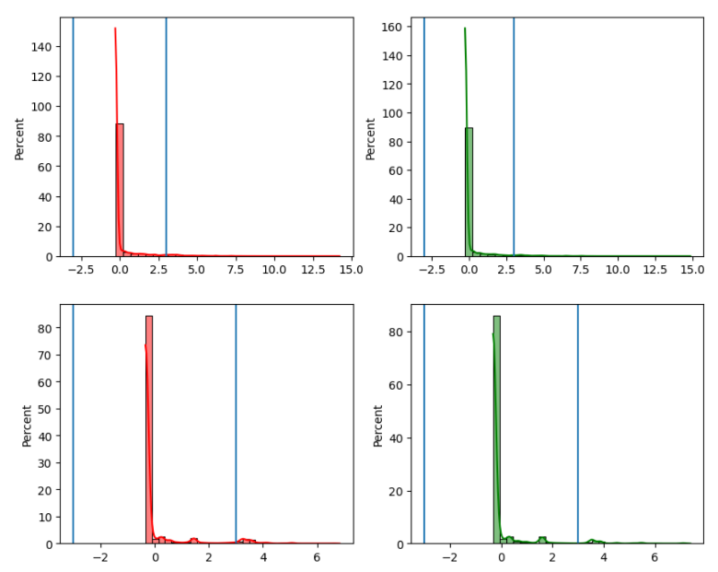

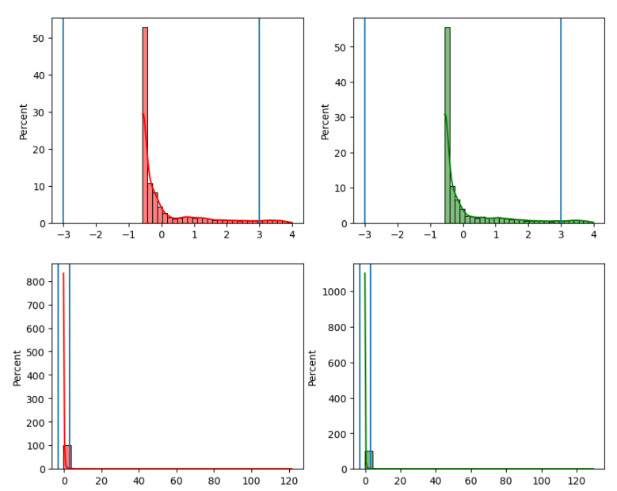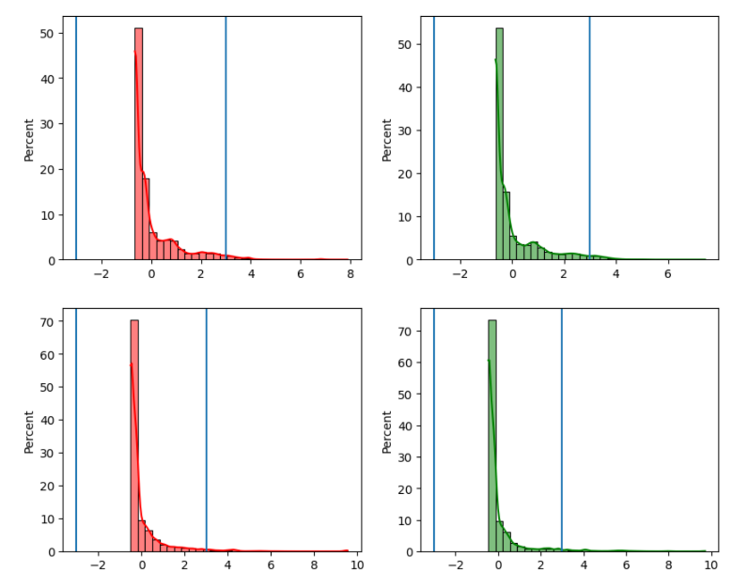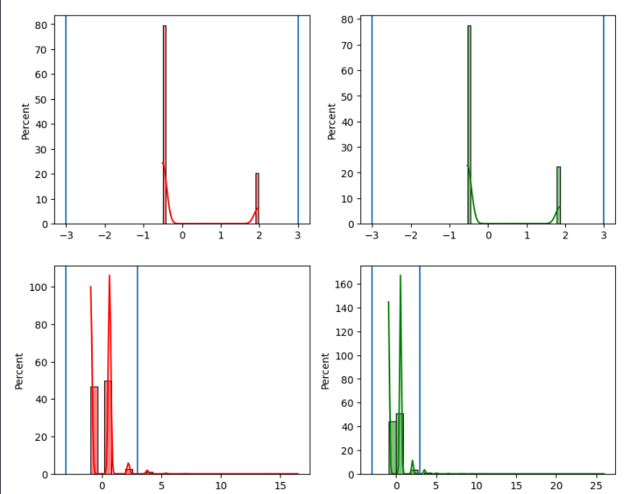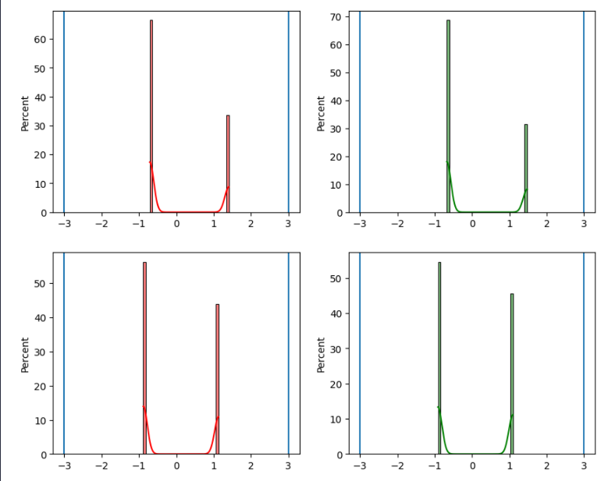

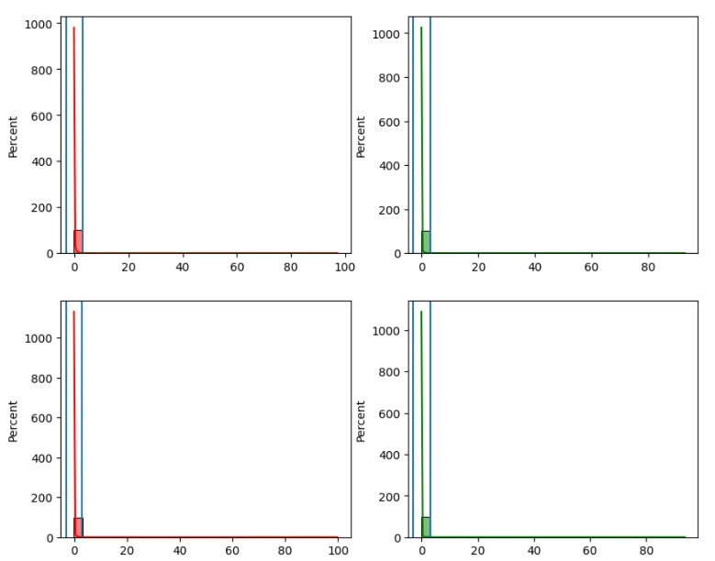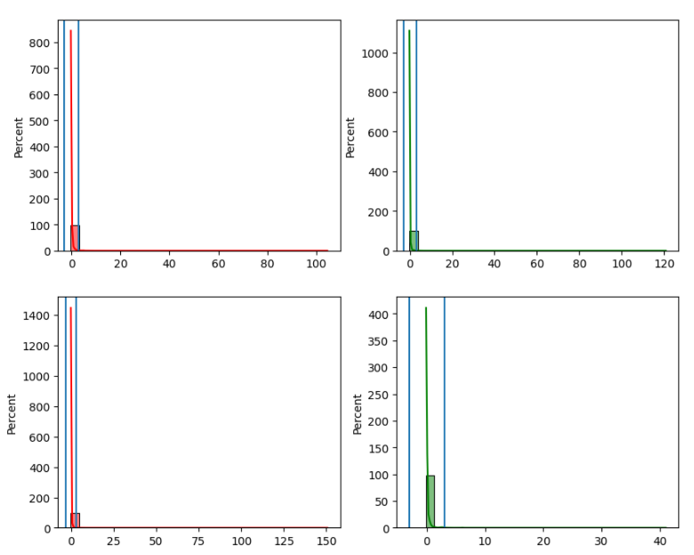

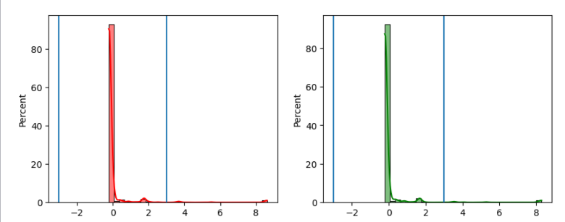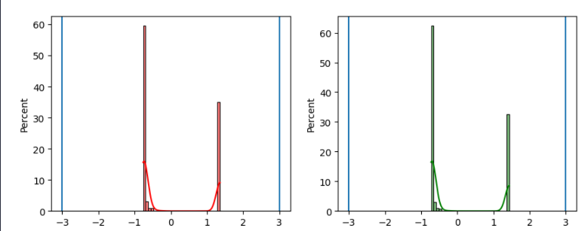

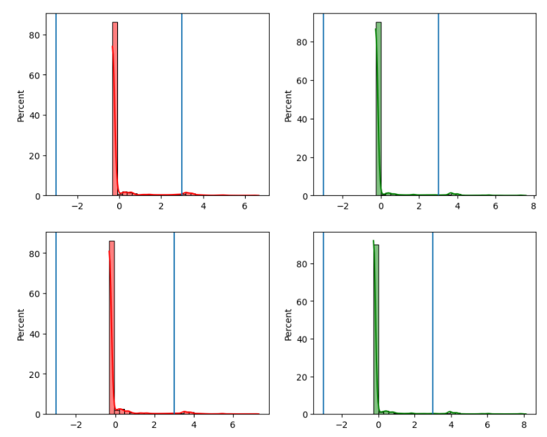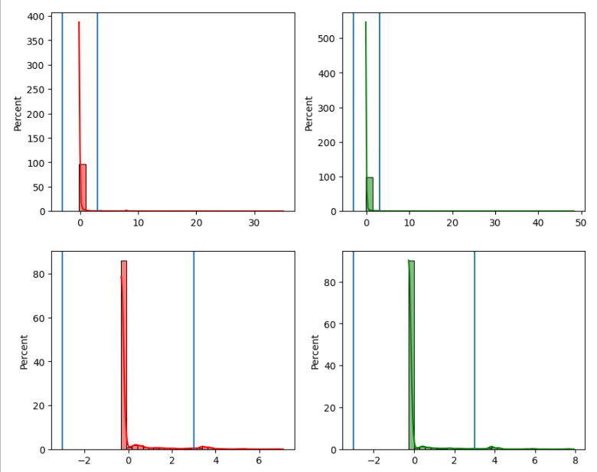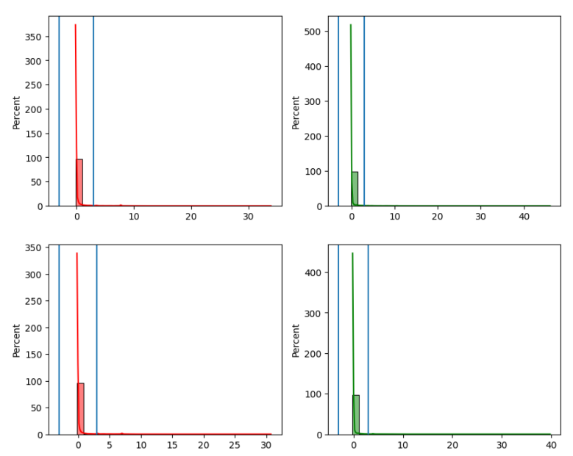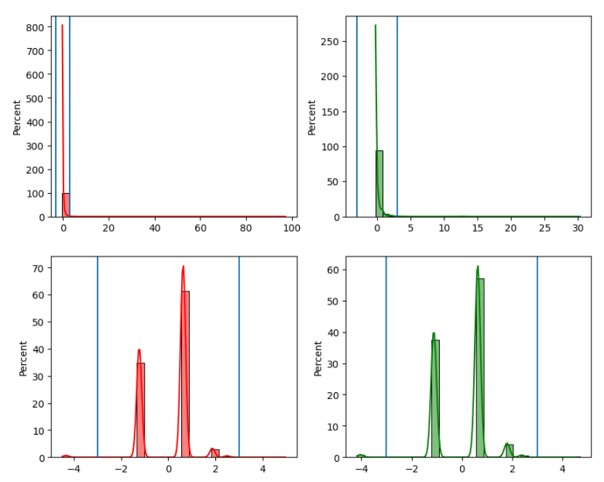

**3rd Approach**

We applied Kmeans to the our data with K=2 and then applied approach number 1&2 on the distance from each point to the center of its cluster.

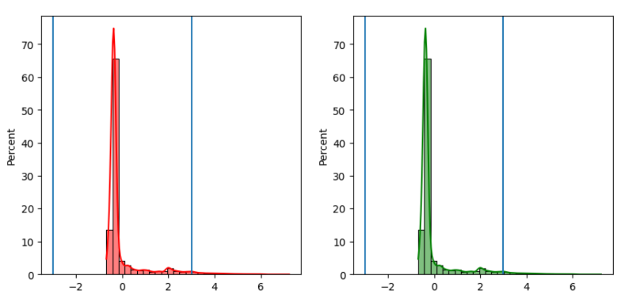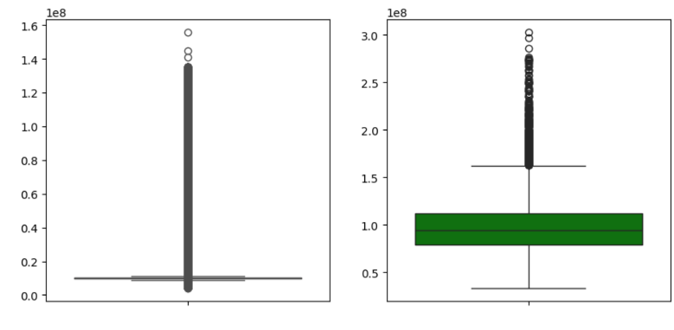We found that number of points in 1st cluster = 120876 and number of points in 2nd cluster = 12235 where percentage of cluster 2 to cluster 1 = 0.1.

**4th Approach**

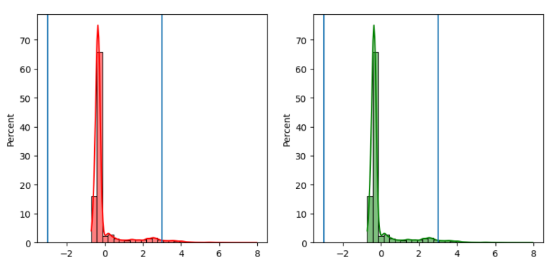We applied 3rd approach but instead of using Kmeans we considered Trojan points as a cluster and Benign points as another cluster. Then applied approach number 1&2 on the distance from each point to the center of its cluster where number of points in Trojan cluster = 68012 and number of points in Benign cluster = 65099.

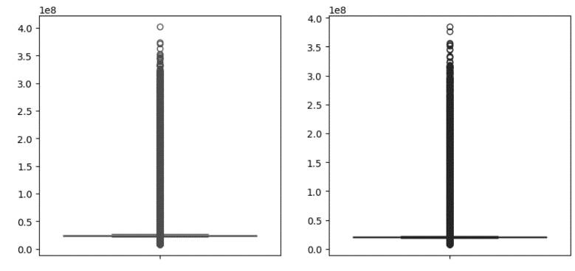

**5th Approach**

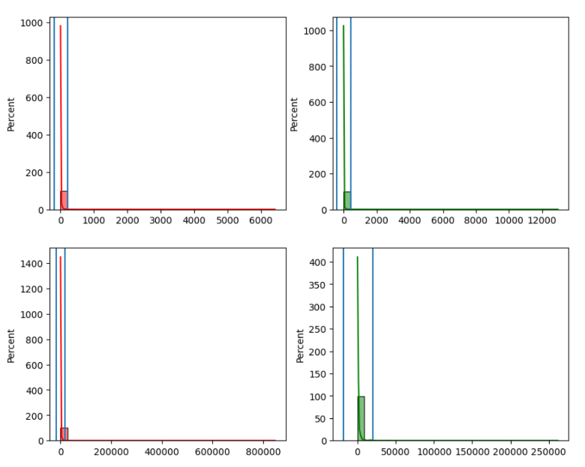For every feature per class, we get its mean and standard deviation. Where any point is greater than mean() + std() or less than mean() – std() will be considered an outlier.

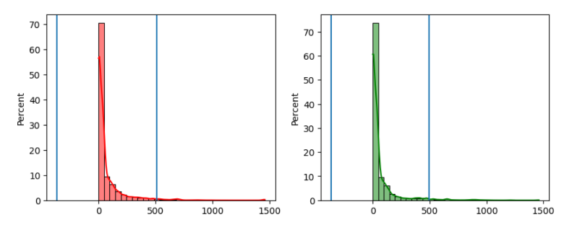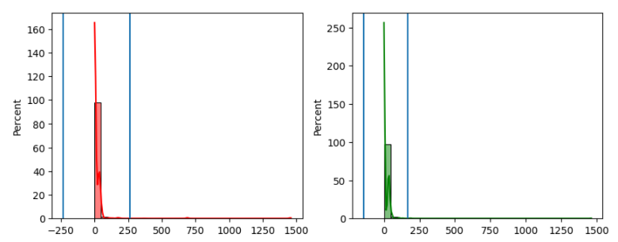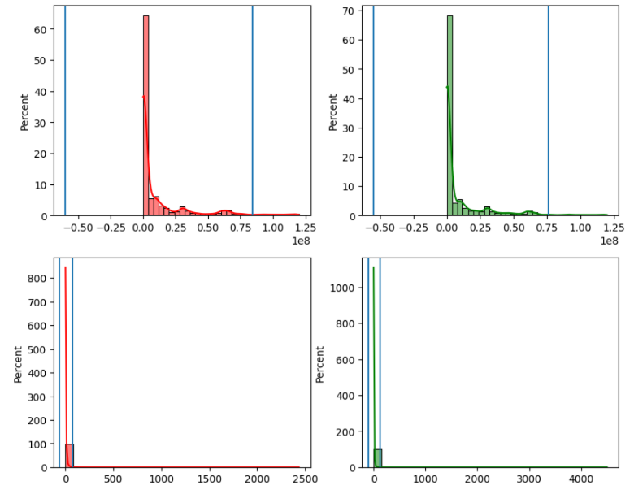

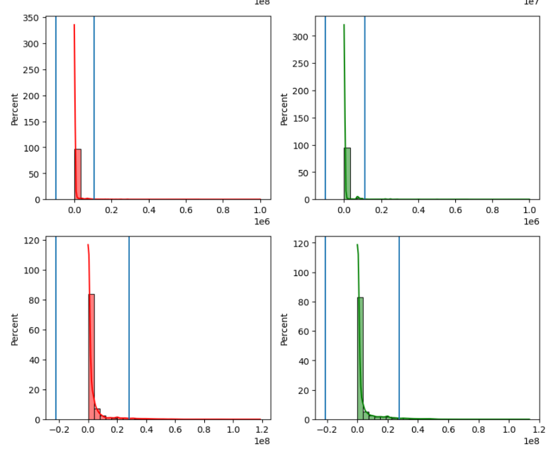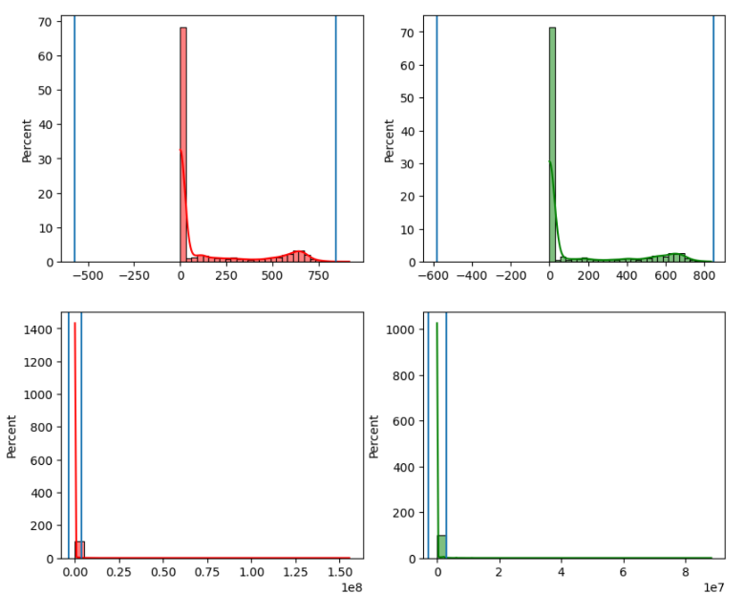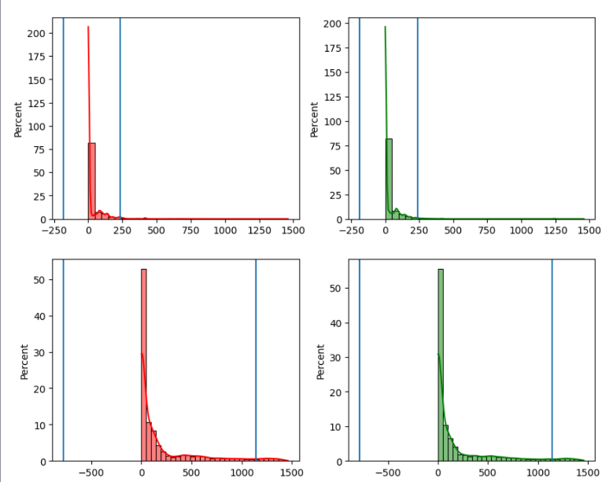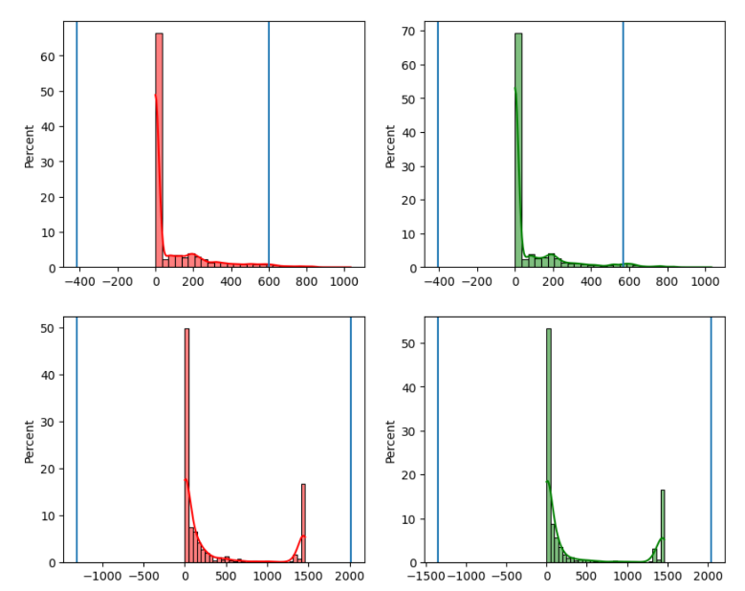

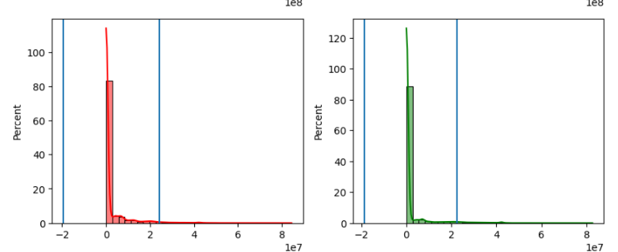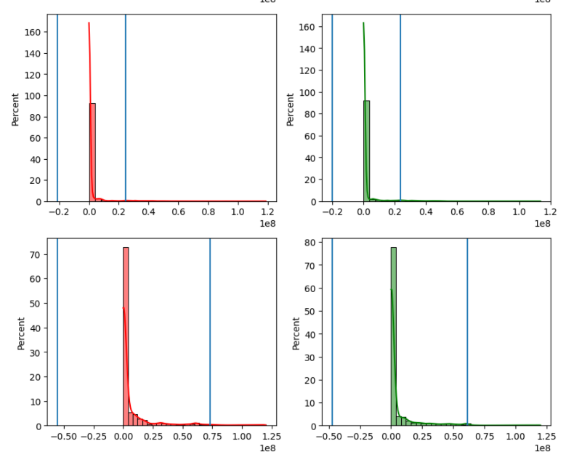

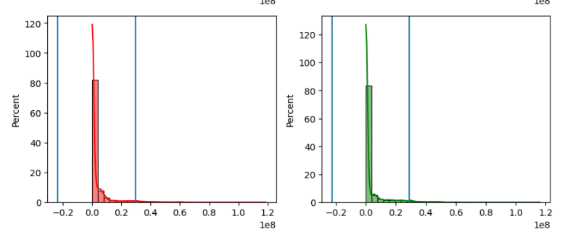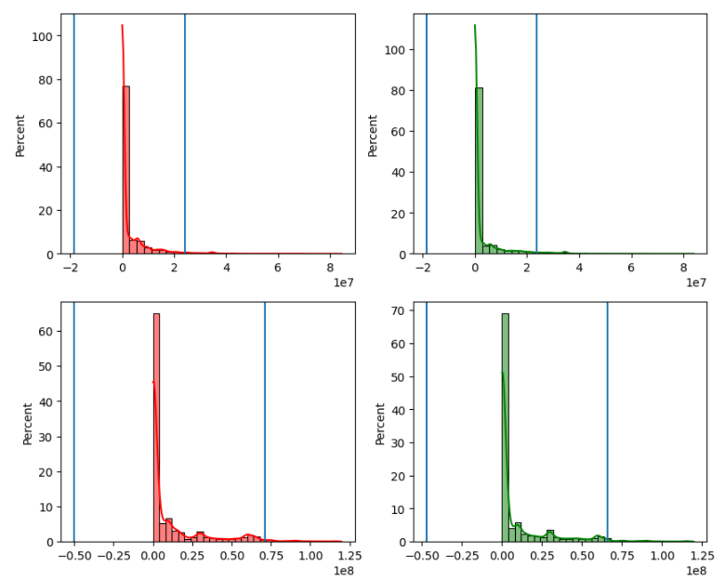

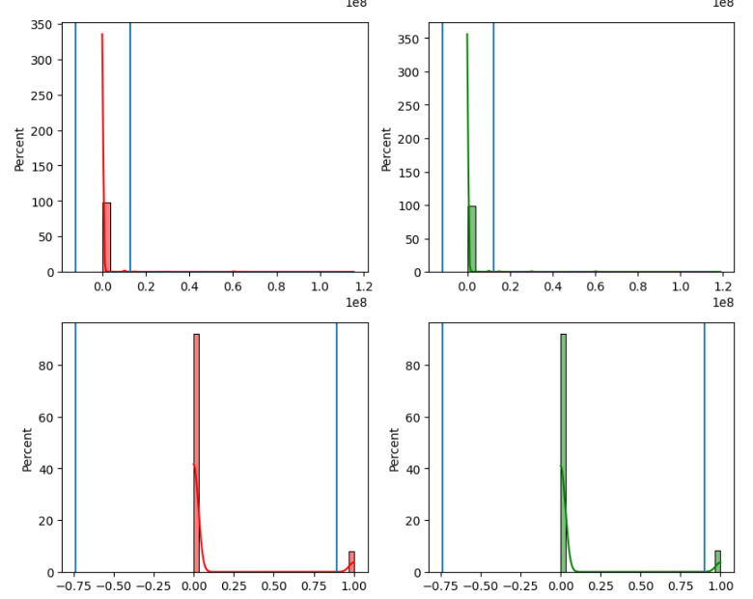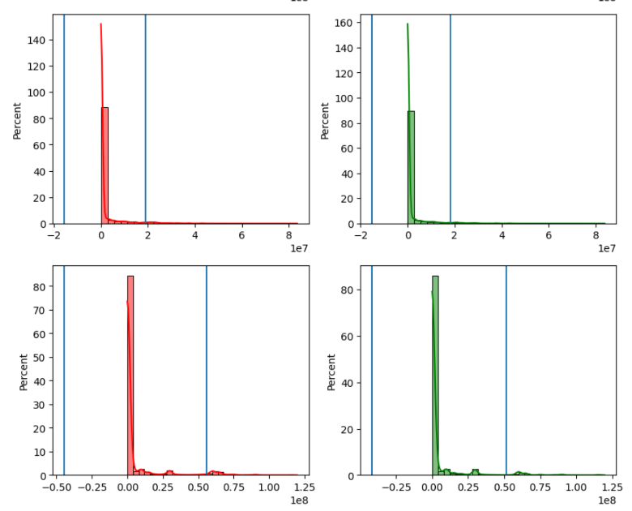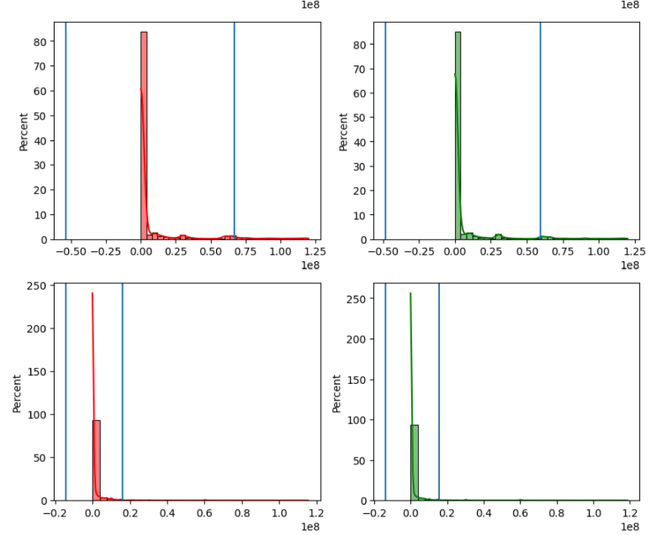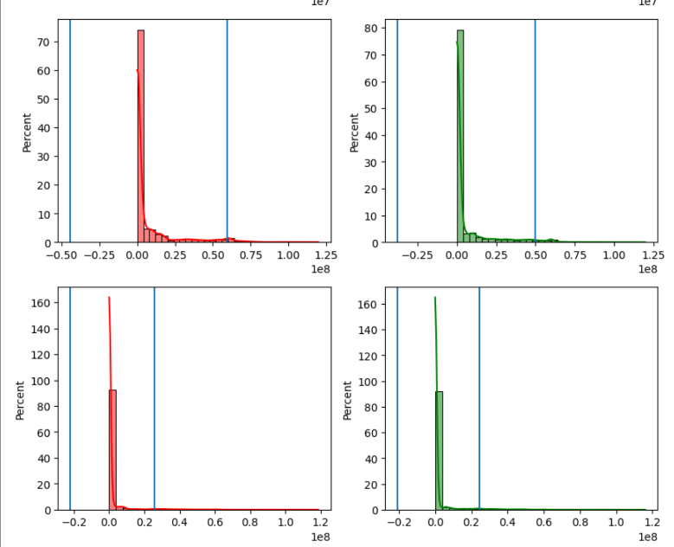

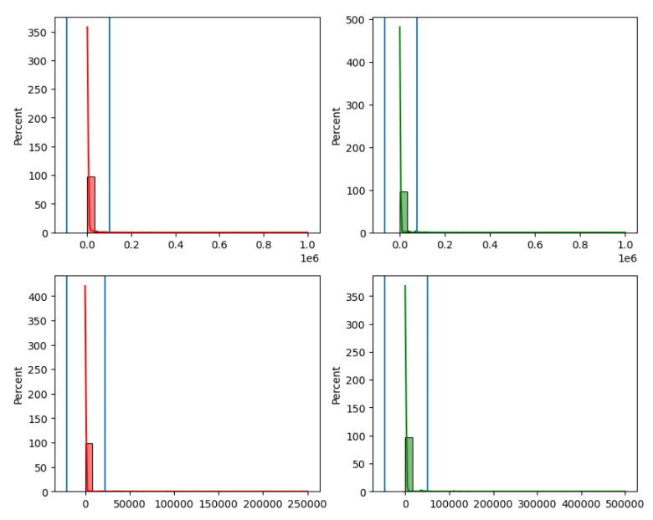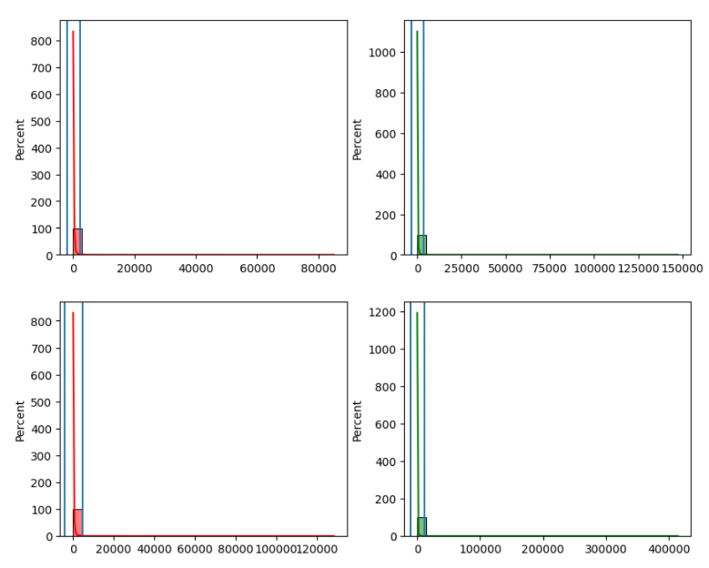

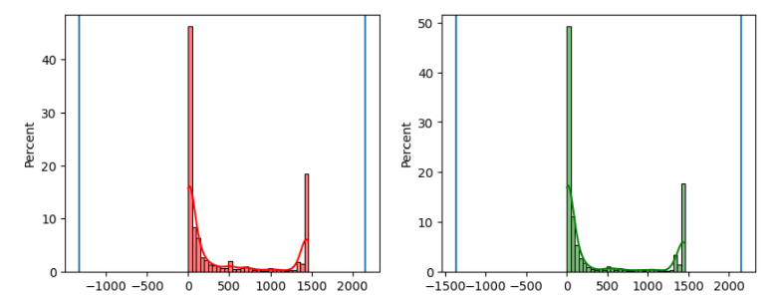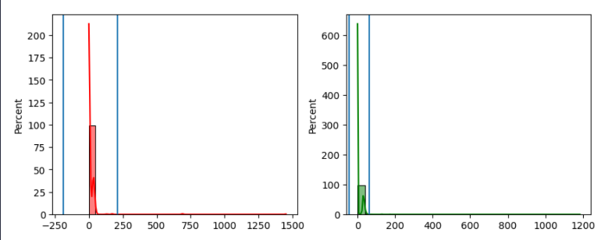

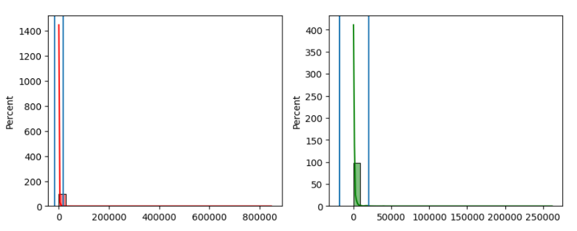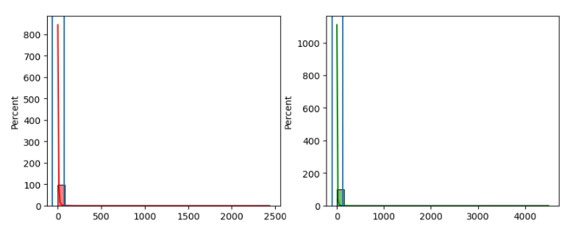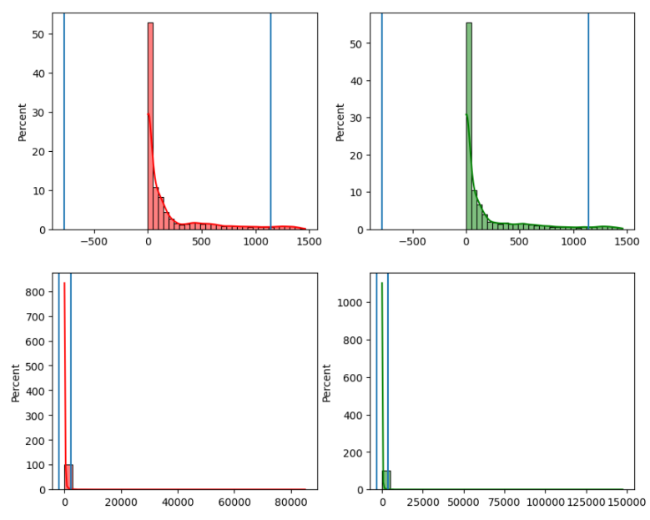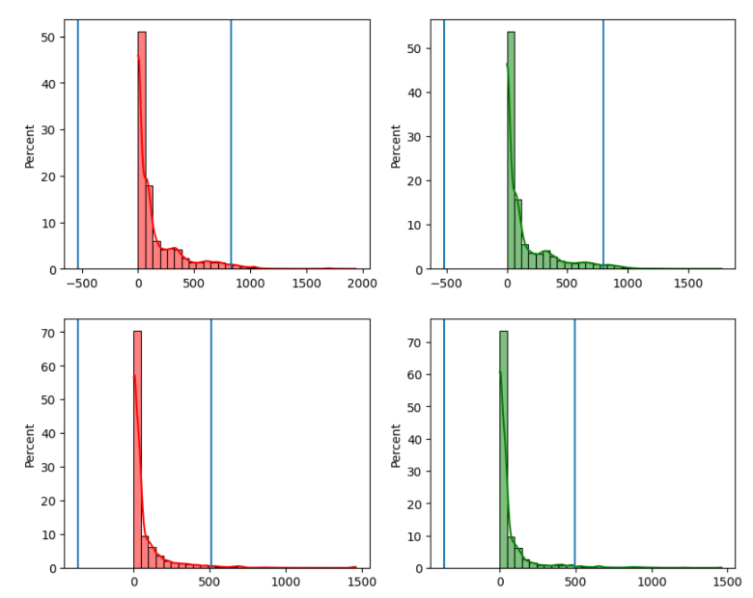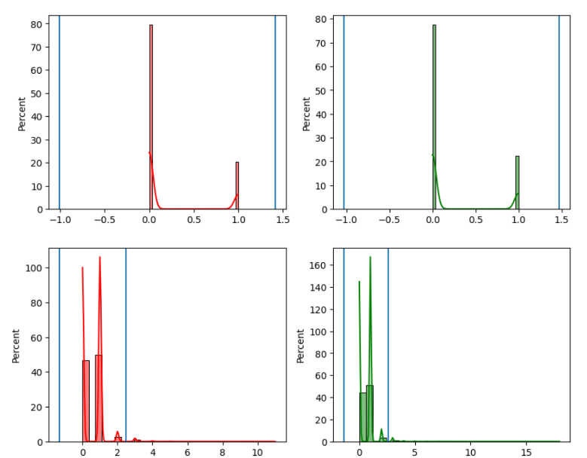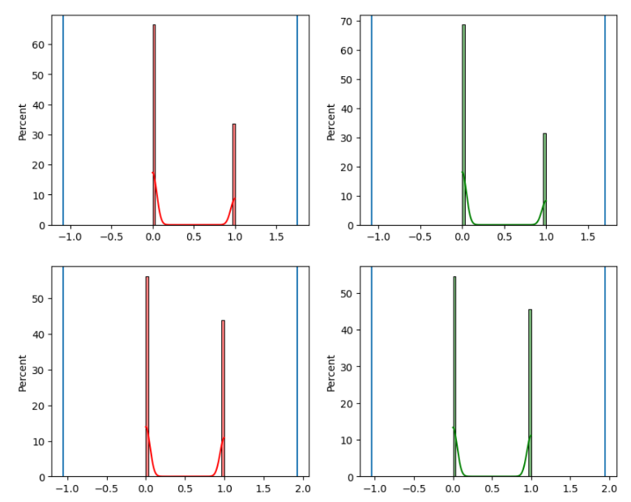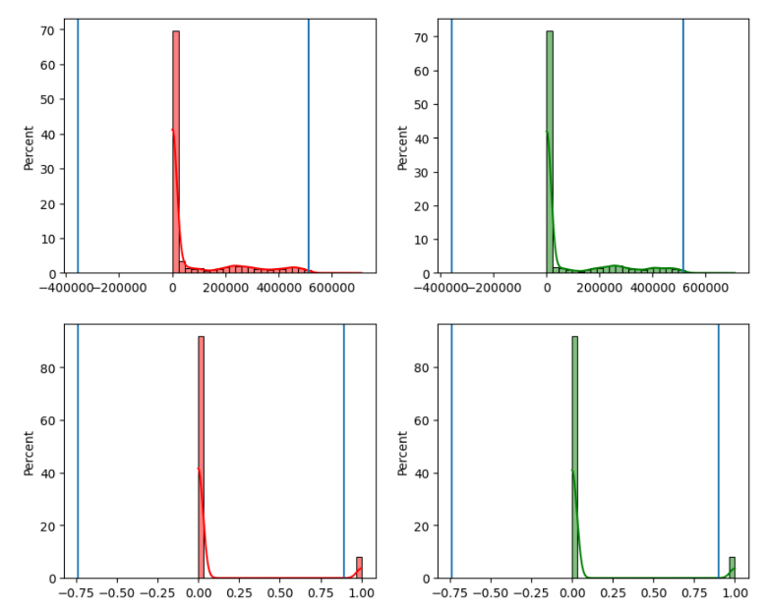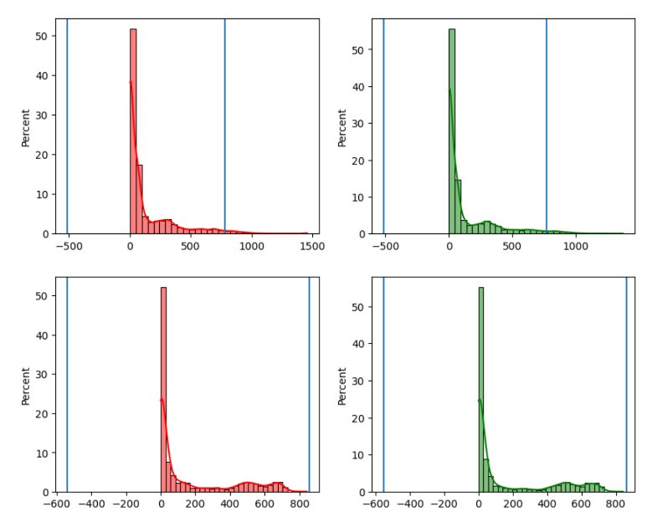

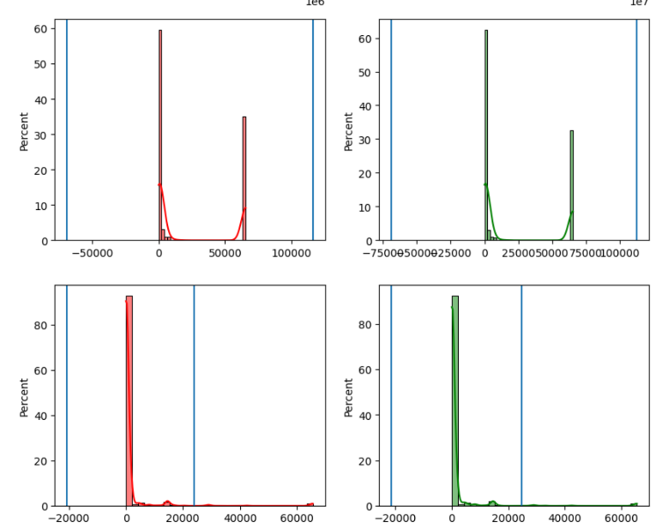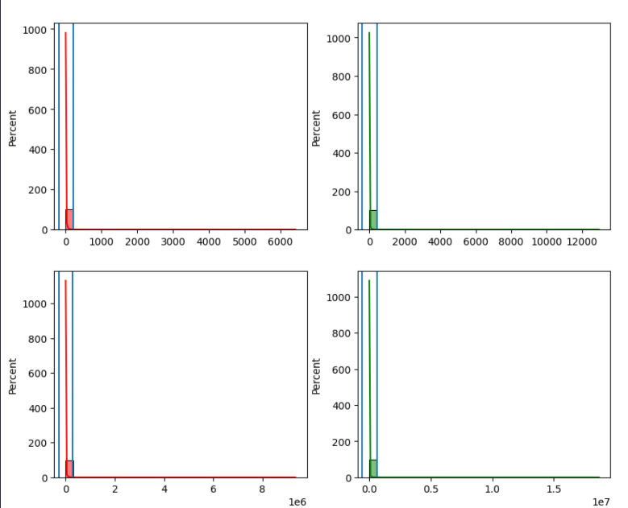

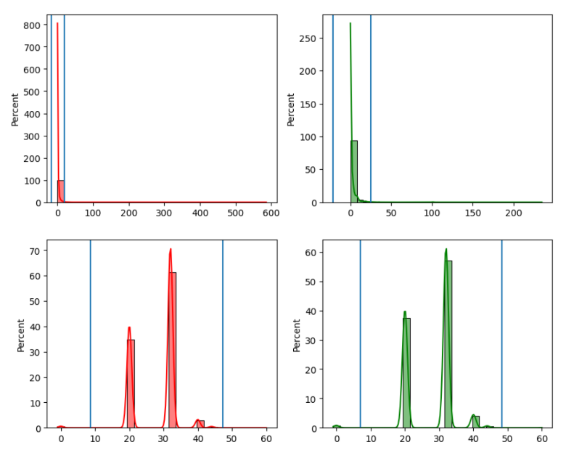

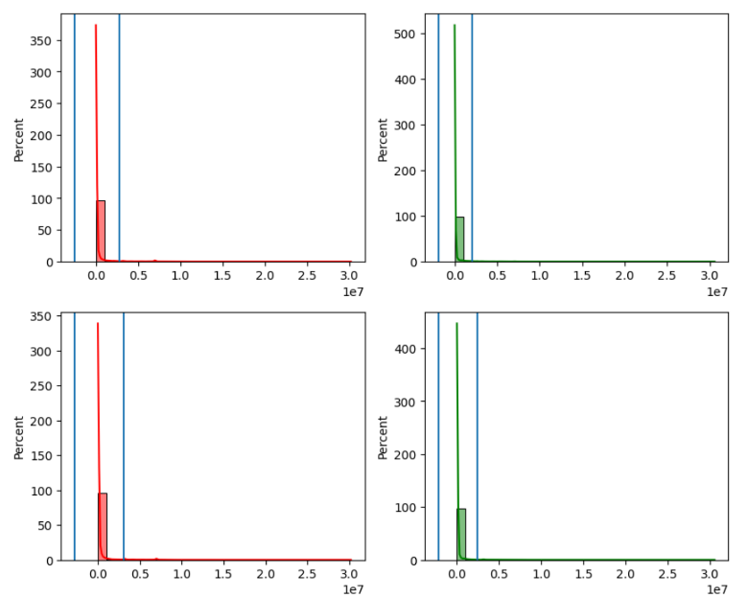

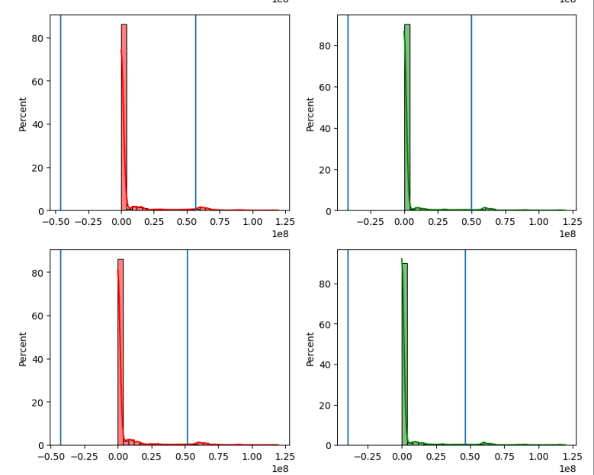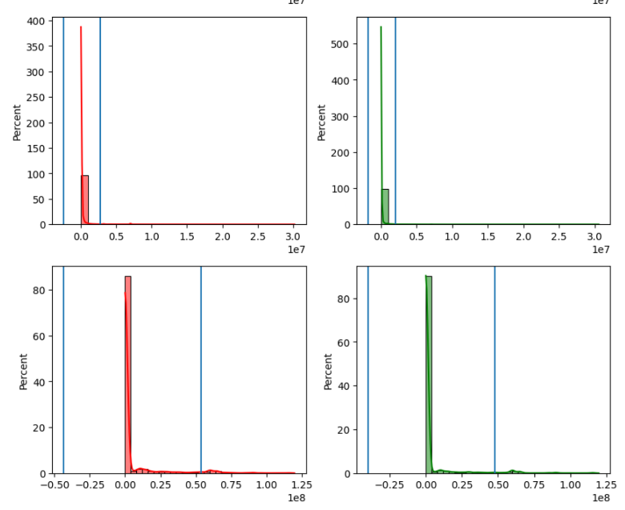

**Voting Result**

After using the above approaches, the voting graph probability of points is as follows:

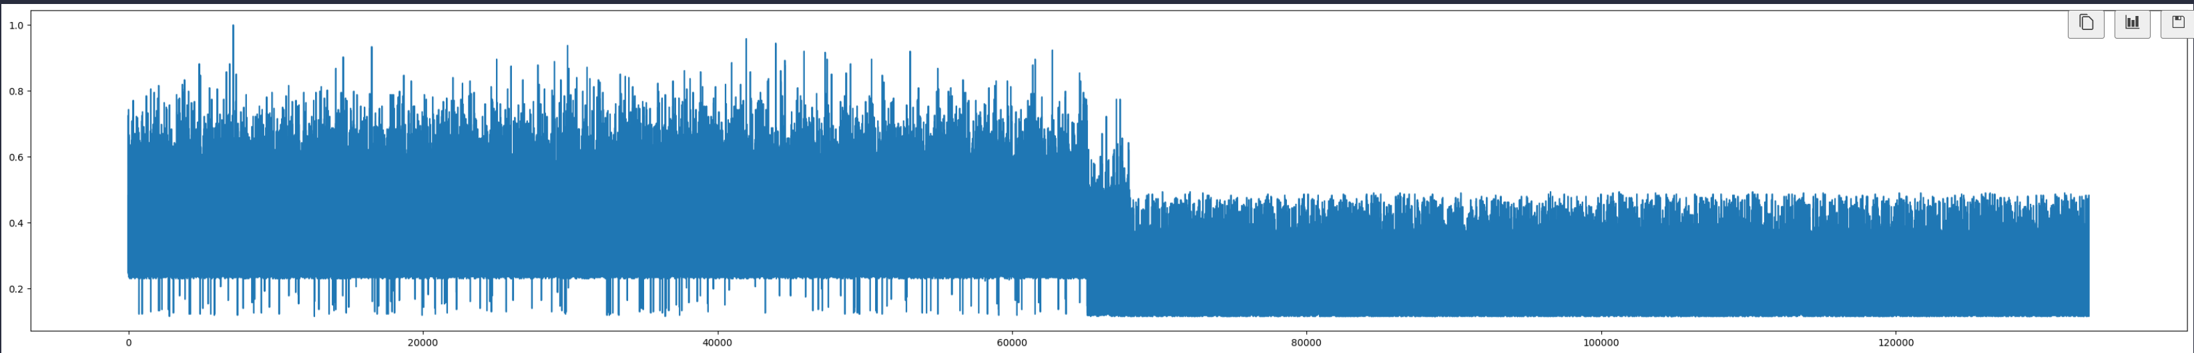

Where we put a threshold around 0.6 that any point has a voting greater than or equal to this threshold will be considered an outlier.

thus the number of points to be removed = 3818 and it's proportion of the training data = 2.86%.

**Feature Correlation**

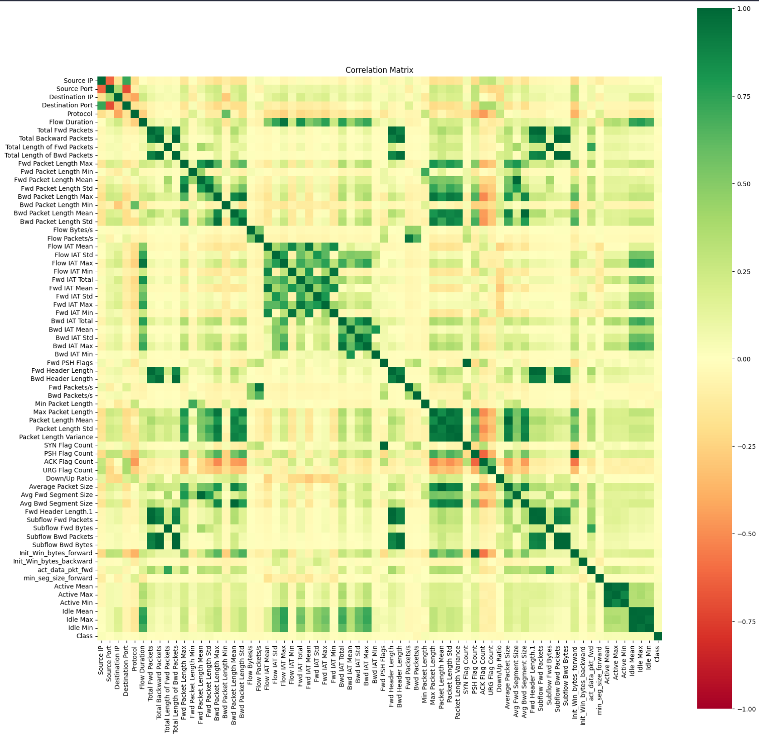We applied feature correlation to discover that there are many features that are correlated to each other so many features are redundant but more importantly we found that all of these features have a corresponding correlation to the class around 0. Which indicates that these features aren’t good estimate for this problem.

**Correlated Feature to the Class**

We computed correlation of each feature to the class then we only kept features that absolute correlation of more than 0.02:

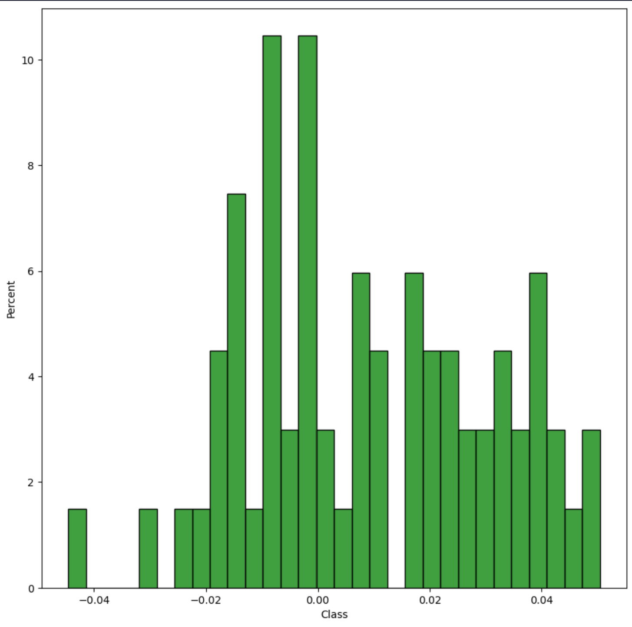

The resultant features we kept have the following correlation with the class (we only kept 27 features from that step):

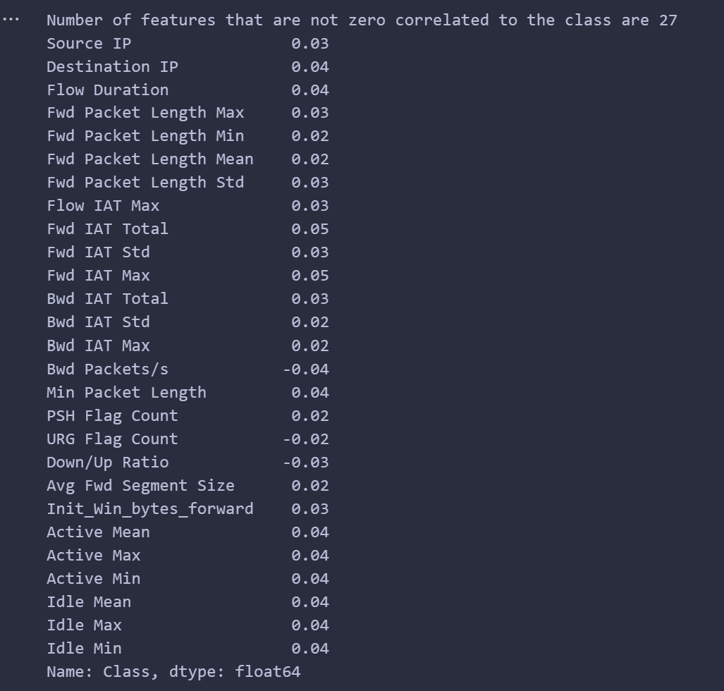

**Important Features**

We then computed information gain for every of the above 27 features kept only the features that have information gain higher than 0.02, so we are left with only 12 features.

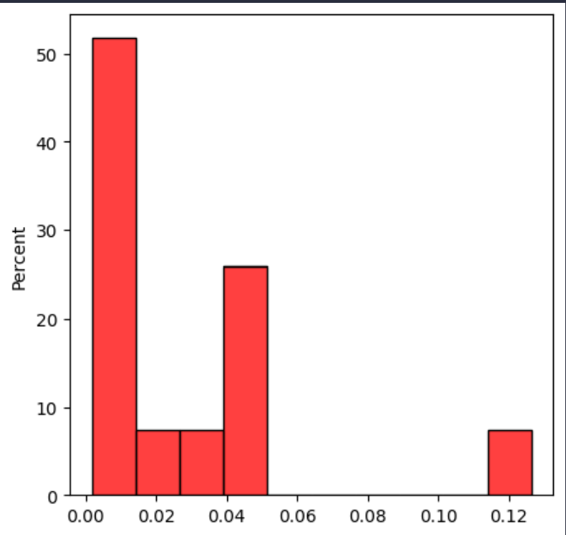

And these 12 features are:

'Source IP', 'Destination IP', 'Flow Duration', 'Fwd Packet Length Max',

'Fwd Packet Length Mean', 'Fwd Packet Length Std', 'Flow IAT Max',

'Fwd IAT Total', 'Fwd IAT Max', 'Bwd Packets/s', 'Avg Fwd Segment Size',

'Init_Win_bytes_forward'

**Feature Normalization**

We computed the mean and standard deviation of the training data then normalized it and normalized the testing data using the mean and standard deviation of the training data. Encoding of IP addresses of the test data is encoded using the same encoding of the training data where unseen IP addresses will be given an ID of -1. Some features had a standard deviation of 0, so we added a small value to it to avoid divide by zero.

**Data separability**

from the above we can see that the interference between data points is very big that finding any separator that can split the classes of the points is very hard and we can visualize the data as follows:

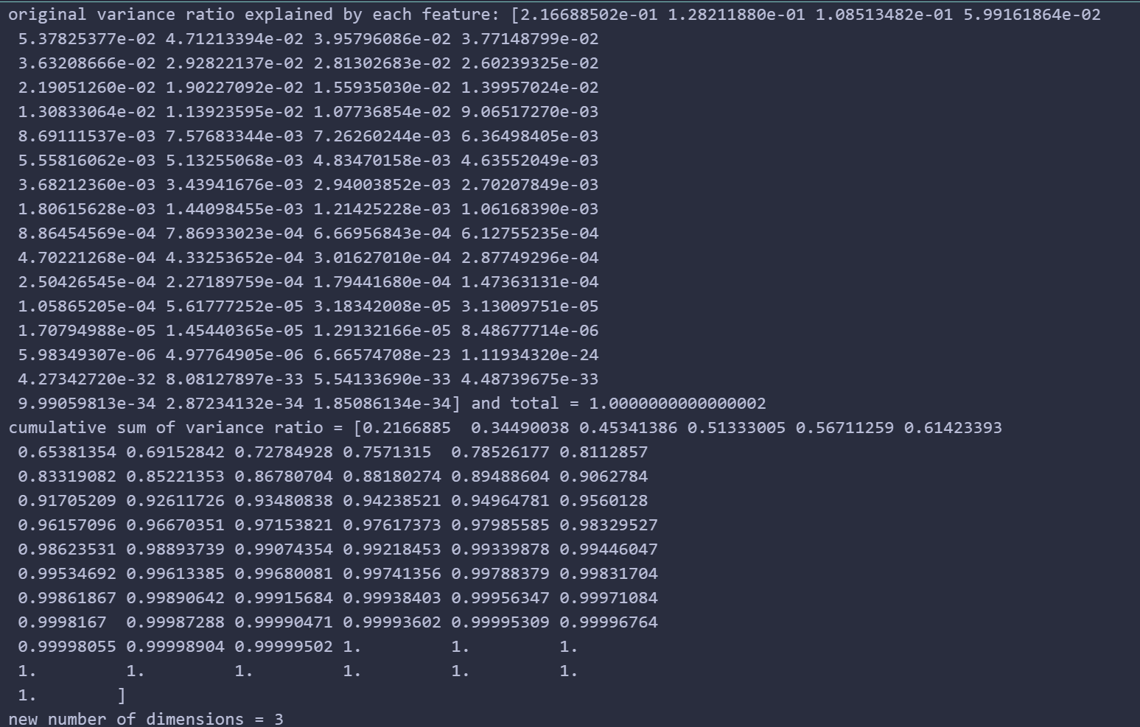we computed the PCA of the feature vector space and only kept the highest 3 vectors representing the highest 3 variance in data preserving around 45% of the variance in data and applied that transformation:

the data has become a 3 dimensional data that can be visualized, we plotted 2 dimensional data as x and y coordinates where the size of the point is the third dimensional feature. The Color of the point represents its class:

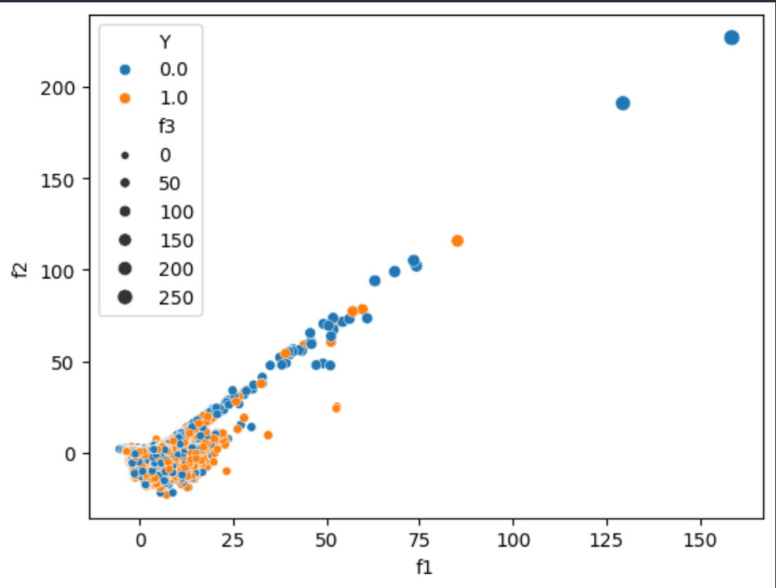

We then plotted the same graph but instead of size of point representing 3rd dimension, we used z axis to represent the 3rd dimension:

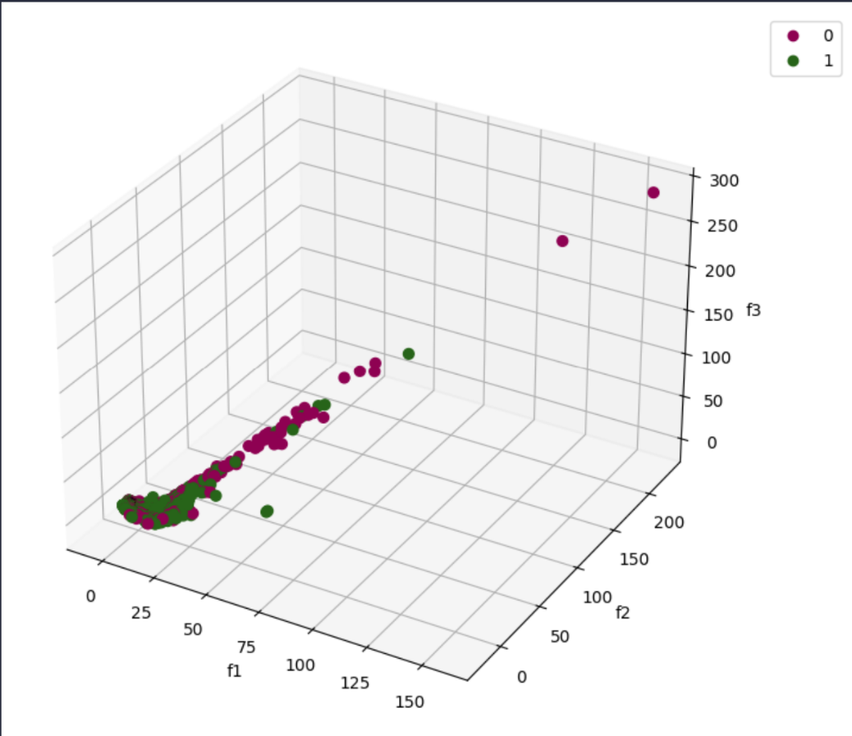

From the above 2 graphs, we can see there is a huge interference between the 2 classes data points. And finding that separator would be nearly impossible that’s why our traditional models has resulted in poor accuracy.

**ZeroR Model**

This model always predicts the test data to have a class of the most frequently seen class in the training data. This model does not have any parameters to optimize.

**Dataset (modified)**

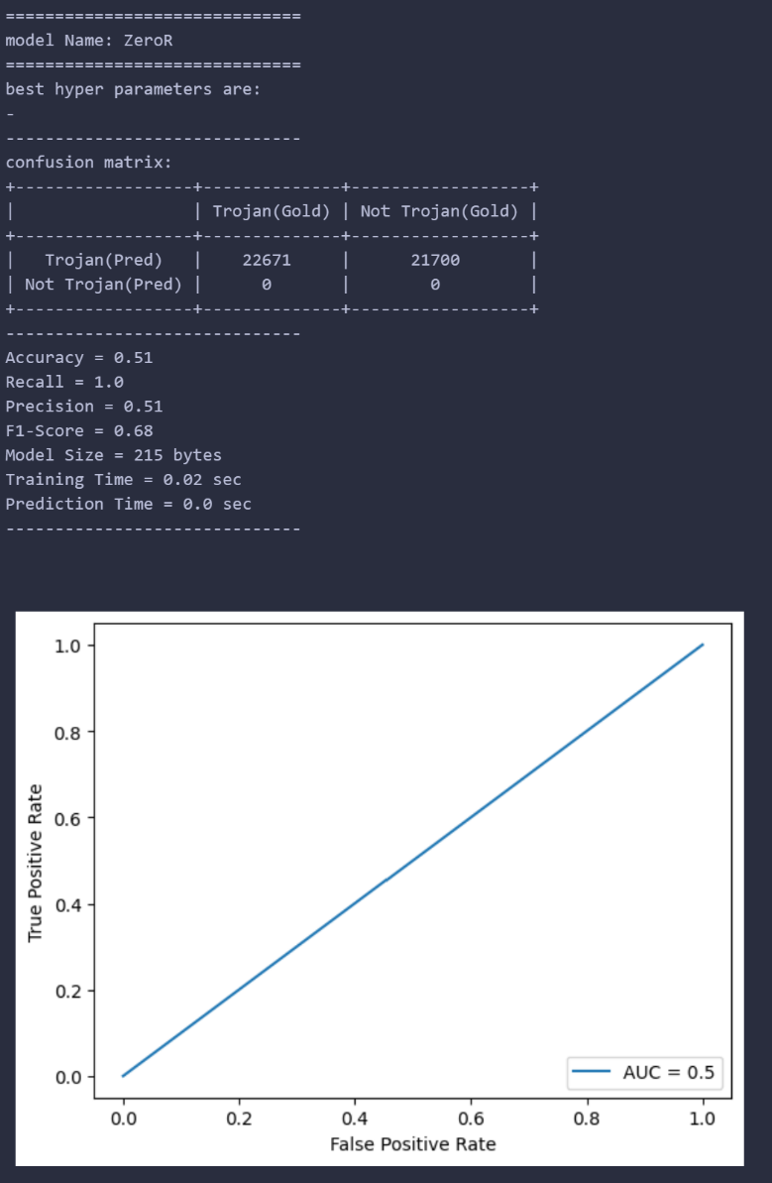

**Dataset (un-modified)**

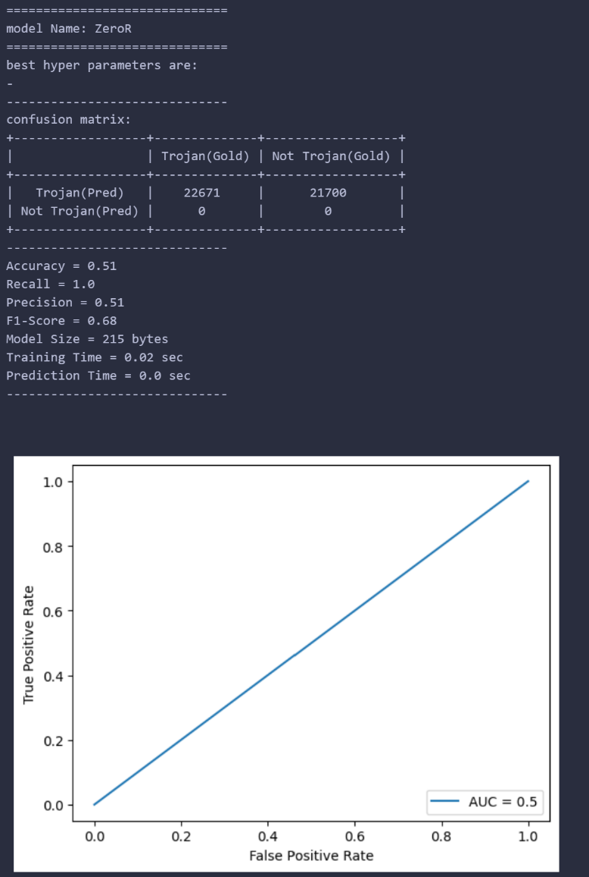

As you notice, zeroR will always result in 100% recall. our feature extraction and analysis didn’t result in improvements and it shouldn’t.

**Logistic Regression Model**

logistic regression is just some combination of weights multiplied to the data points features to predict the class of the model.

We applied Grid Search with K - cross Validation of K=5 on the following parameters with following values:

1. **Penalty:** ‘l2’, ‘l1’, ‘elasticnet’.
2. **C:** ‘0.01’, ‘1’, ‘100’.
3. **Solver:** ‘lbfgs’, ‘liblinear’, ‘newton-cg’, ‘newton-cholesky’, ‘sag’, ‘saga’.
4. **max_iter:** ‘100’, ‘1000’, ‘10000’.
5. **multi_class:** ‘auto’, ‘ovr’, ‘multinomial’.

This resulted in around 486 candidates with 2430 fits. Grid Search Completed in around 10 minutes.

The best validation accuracy we could get is 0.53.

The following were found to be the best parameters:

* **C:** 0.01
* **max_iter:** 100
* **multi_class:** auto
* **penalty:** l1
* **solver:** liblinear

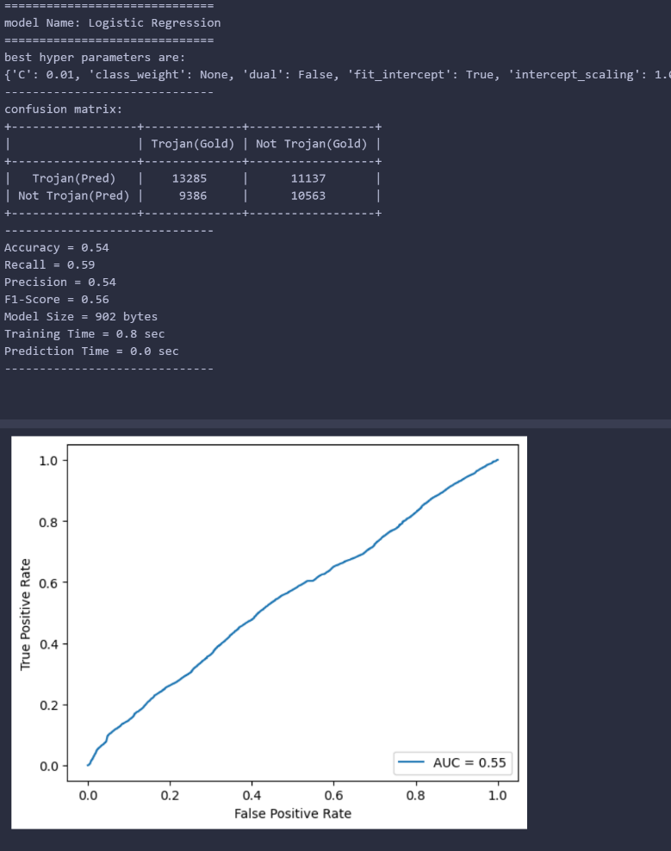

**Dataset (modified)**

**Dataset (un-modified)**

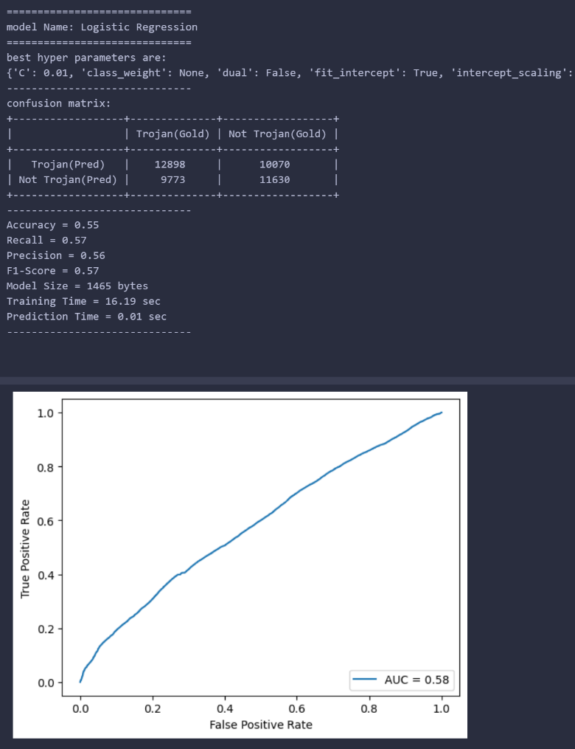

As you can see, our feature analysis and extraction results in:

* 1% lower accuracy
* 2% higher recall
* 2% lower Precision
* 1% lower F1-Score
* 62% lower model size
* 1900% faster training time
* 1000% faster prediction time
* 7% lower AUC

**Support Vector Machine Model**

Support vector machine is just finding a linear separator or converting non-linear separable data into linear separable where this linear separator will have the highest margin between its support vectors.

We applied Grid Search with K - cross Validation of K=5 on the following parameters with following values:

1. **degree:** ‘3’, ‘7’, ‘l1’.
2. **C:** ‘0.01’, ‘1’, ‘100’.
3. **kernel:** ‘linear, ‘poly’, ‘rbf’, ‘sigmoid’.
4. **Gamma:** ‘scale’, ‘auto’.
5. **max_iter:** ‘100’, ‘500’, ‘1000’.
6. **decision_function_shape:** ‘ovo, ‘ovr’.

This resulted in around 432 candidates with 2160 fits. Grid Search Completed in around 289 minutes.

The best validation accuracy we could get is 0.51.

The following were found to be the best parameters:

* **C:** 1
* **decision_function_shape:** ovo
* **degree:** 3
* **gamma:** auto
* **kernel:** poly
* **max_iter:** 100

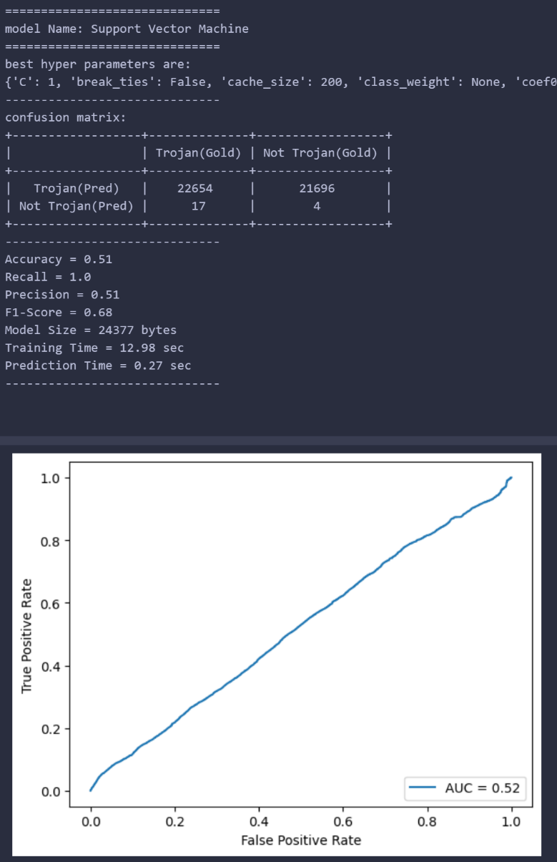

**Dataset (un-modified)**

**Dataset (modified)**

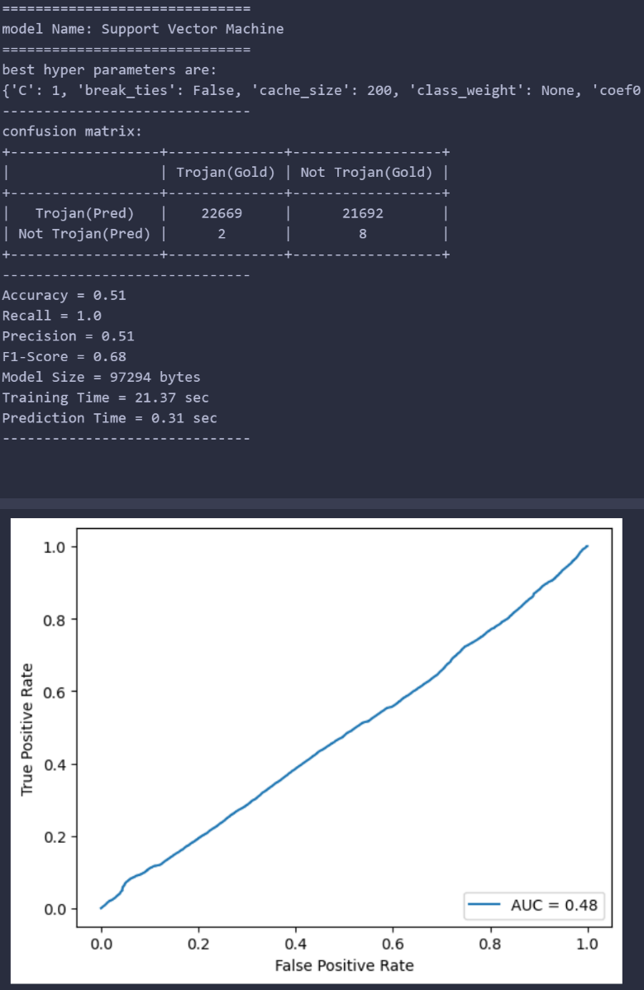

As you can see, our feature analysis and extraction results in:

* 0% change in accuracy
* 0% change in recall
* 0% change in Precision
* 0% change in F1-Score
* 300% lower model size
* 64% faster training time
* 15% faster prediction time
* 8% higher AUC

**Adaptive boosting Classifier Model**

Adaboost is just using many classifiers where every classifier tries to improve the result of the preceding classifier during training and at the end, every classifier votes to the classification of a point using a weight given to it during training.

In our Adaboost model, we are using Decision trees with depth=1 (stamp) as our basic classifiers.

We applied Grid Search with K - cross Validation of K=5 on the following parameters with following values:

1. **n_estimators:** ‘10’, ‘100’, ‘1000’.
2. **learning_rate:** ‘0.01’, ‘1’, ‘100’.
3. **algorithm:** ‘SAMME, ‘SAMME.R’.

This resulted in around 18 candidates with 90 fits. Grid Search Completed in around 15 minutes.

The best validation accuracy we could get is 0.73.

The following were found to be the best parameters:

* **algorithm:** SAMME.R
* **learning_rate:** 1
* **n_estimators:** 1000

we notices the increasing the number of estimators increases the test accuracy. So we put n_estimators to be 5000 not 1000 as after 5000 we noticed only a small change in the accuracy.

**Dataset (modified)**

**Dataset (un-modified)**

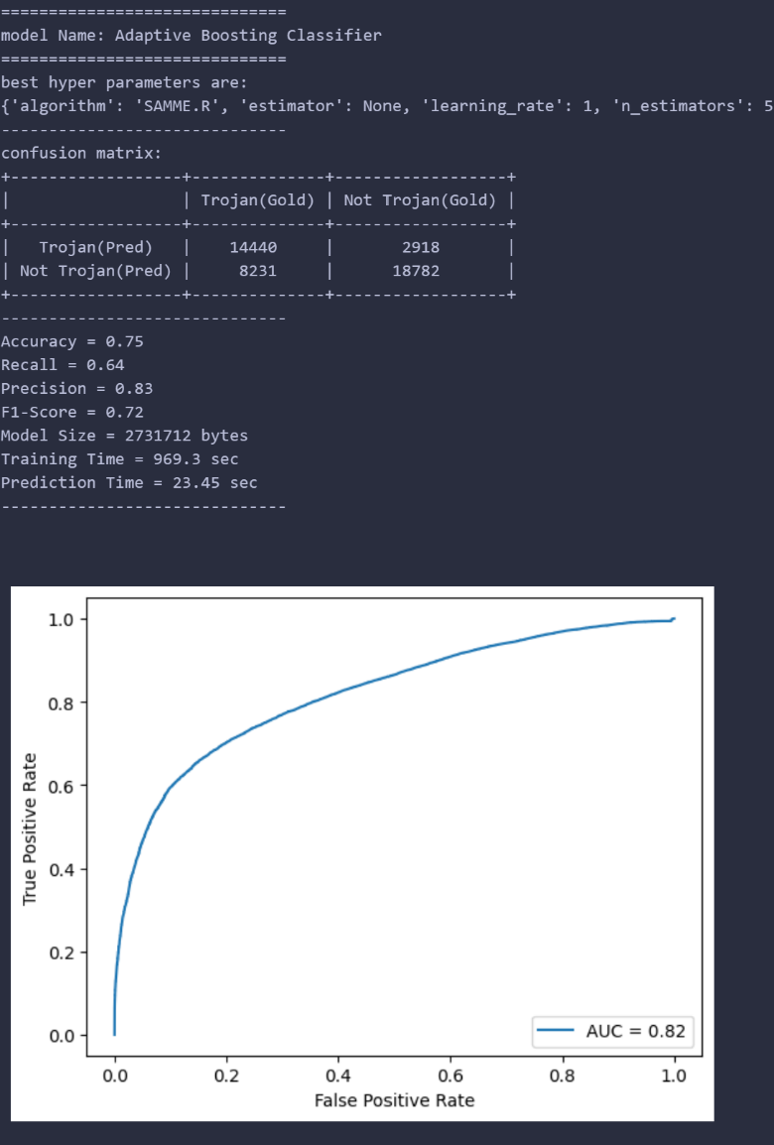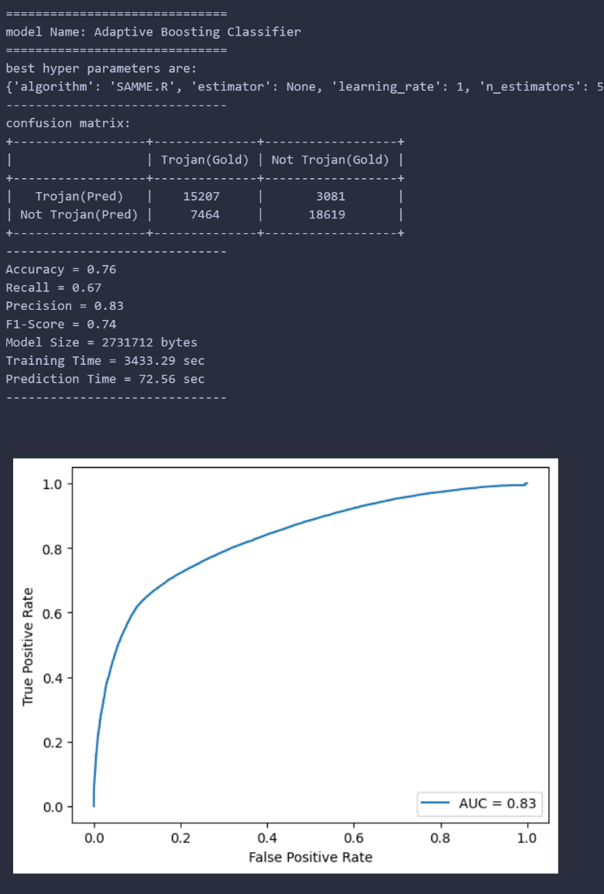

As you can see, our feature analysis and extraction results in:

* 1% lower accuracy
* 3% lower recall
* 0% change in Precision
* 2% lower F1-Score
* 0% change in model size
* 250% faster training time
* 213% faster prediction time
* 1% lower AUC

**Other Models**

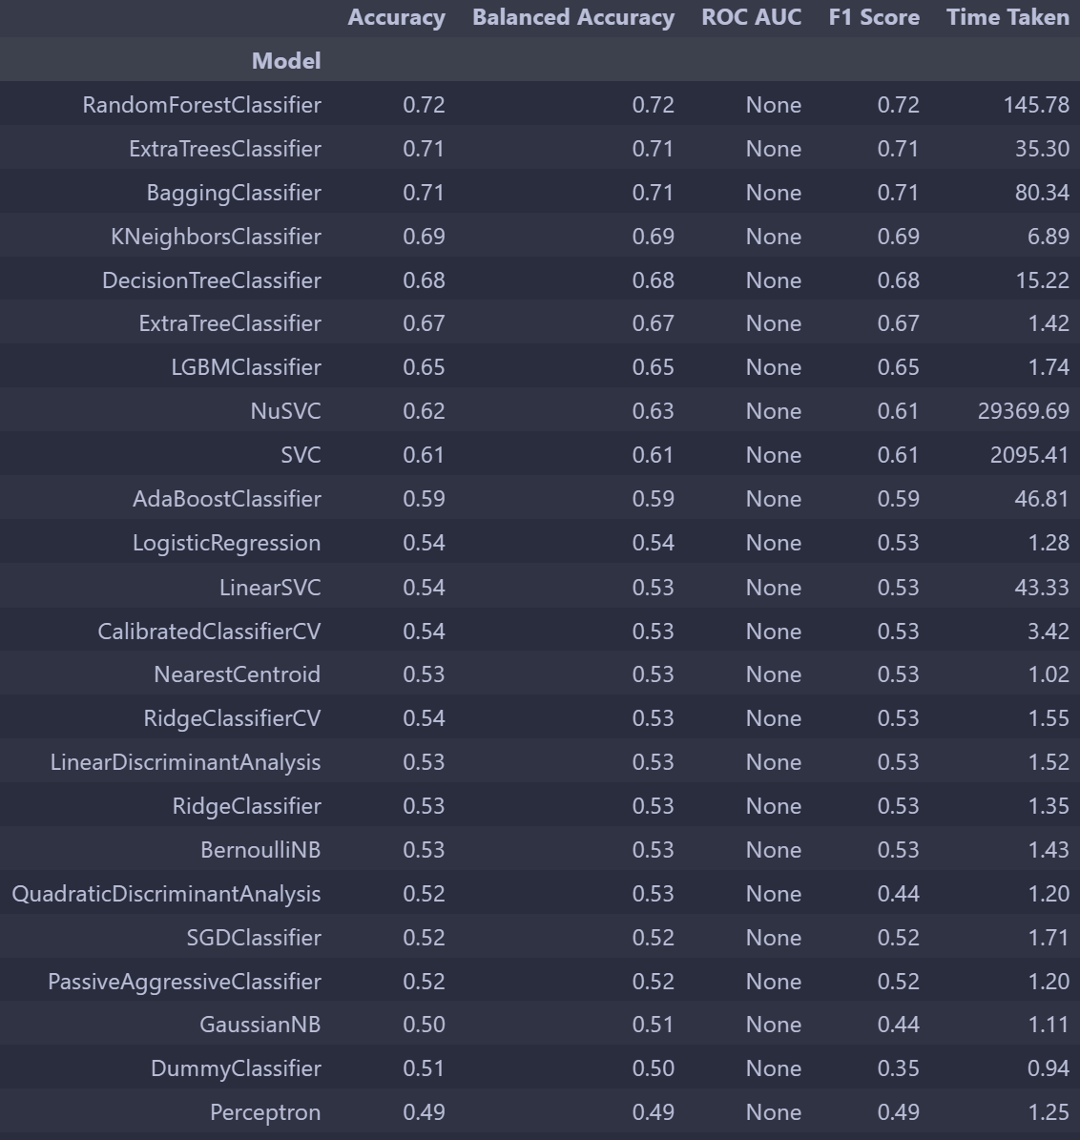We used a package called LazyClassifier that trains multiple different Sklearn models on our models and give some insights on what models would be better for our data and here are the results:

**Experimental Results**

1. We tried to convert IP addresses from Format ‘A.B.C.D’ into the Format ‘AAABBBCCCDDD’ so for example an IP address having a value 10.42.0.4 will be 010042000004 and so on but this yielded very big numbers and we decided the number isn’t representative of the address and using other techniques as label encoder (we dealt with the IP address as categories) and using one hot encoder for IP address would just increase the feature vector space dramatically.
2. We tried PCA to reduce the dimensions of our feature vector space from 67 to 20 preserving around 95% of the variance but it didn’t improve the accuracy so we used other feature selections approach.

**Other Approaches**

We only found another one notebook that achieved an accuracy around 95% using SVC but we found 2 problems with that notebook like:

* He used training data with test in feature analysis and extraction.
* He considered around 75% of training data to be outliers.

After fixing these problems in his notebook, the SVC he used resulted in around 49.7% accuracy.

**Conclusion**

1. Either the distribution of the data is very hard to separate from each other or the labeling of the data is incorrect.
2. Using feature engineering on such data didn’t improve accuracy (decreased the accuracy by a very small number) but made both training and prediction faster significantly. Whereas the model size decreased significantly.
3. Many features are correlated with each other meaning that they have the same meaning.